PFIZER SWEDEN
Regional Landscape Mapping

Project | VS-2026-PFI-001
Vendor | Viti Science AB
Client | Pfizer Sweden — Access & Value
Version / Date | v2 · 2026-04-26

Executive summary
Sweden does not have one pharmaceutical market. It has twenty-one. Each region holds budget authority, runs its own access committee, and sits inside one of six sjukvårdsregioner that coordinate where coordination helps. NT-rådet and NSG primarily coordinate and recommend at the national tier; TLV is a state authority that makes binding reimbursement decisions for medicines within the pharmaceutical benefits system. The result is real heterogeneity in what gets prescribed, by whom, and at what speed, and it is precisely that heterogeneity that determines where Pfizer's eleven products thrive or stall.
We pulled four years of register data, parsed eighteen of twenty-one regional plans, fact-checked the leadership of every region against samverkanlakemedel.se and the regional websites, and built a region-by-product opportunity model on top. Every claim that follows is tagged for how confident we are in it.

Five things to take away
- Norrland is a Vyndaqel cornerstone. Norrbotten and Västerbotten together hold 144 of 463 Swedish ATTR-CM patients on Vyndaqel, 31% of the national caseload on 5.0% of the population. The TTR V30M founder variant in the Skellefteå area is the accepted clinical explanation. Strategically, this means the same Norrland clinical centres are the natural home for Hympavzi and, when it lands, Elrexfio.
- Ibrance prescribing declined sharply in Stockholm and Västra Götaland. Both fell sharply between 2021 and 2024 (Stockholm about 33%, VGR about 36%) while Halland, Skåne and Uppsala held flat or grew. The IQVIA Oncology extract 2026-04-27 confirms substitution direction empirically and surfaces Verzenios (Lilly abemaciclib) as the primary CDK4/6 competitor — not Kisqali alone. Across Stockholm, VGR, Skåne and Halland, Verzenios growth in the 2nd half of the IQVIA 36-month window dwarfs Kisqali growth. Cost-driven substitution is plausible working hypothesis, pending IQVIA Kisqali volume validation. The Ibrance decline is observed in Läkemedelsregistret; the substitution interpretation is the working hypothesis supported by the Stockholm regional formulary text.
- Adult vaccines have a real demographic tailwind. Stockholm's over-65 population grows by roughly 35% to 2040, around 146,000 additional elderly residents in the capital alone. Sixteen of twenty-one regions match the Aging archetype. Abrysvo already holds 65% of national RSV vaccine volume despite NT-rådet's formal "avvakta" position; the regional reality and the central recommendation are out of alignment, and that asymmetry is itself an opportunity.
- Eight people carry most of the cross-product narrative. Jan Melin (LK ordförande Uppsala + NT-rådet representative for Mellansverige, composite influence 179.5), Pia Näsvall (HSD Västerbotten + NSG nationellt, 155.0), Mårten Lindström (tf. ordförande NT-rådet, 99.8) and five others sit at the top of a fact-checked map. Most hold dual roles; engaging them once on the broader pipeline is materially more efficient than engaging product by product.
- Of the 231 region × product combinations, 70 fall in Priority Focus, 24 in Engagement Build, 46 in Quick Win, and 91 in Deprioritise. The single most strategically interesting cell is Norrbotten × Vyndaqel, which sits just inside Engagement Build: high opportunity, high archetype concentration, actionability just below the Priority Focus line. One sustained stakeholder investment plausibly moves it across the threshold.

What this points to
Five plays follow from these patterns. P1 anchors Vyndaqel inside Norrland's hereditary-disease care pathway and uses that anchor to land Hympavzi and Elrexfio. P2 defends what remains of Ibrance in the capital belt and frames Tukysa and Talzenna for the same audience. P3 rides the demographic tailwind for Abrysvo and Prevenar 20 across the sixteen aging regions. P4 builds a precision-oncology backbone wherever the molecular testing infrastructure already runs hot. P5 engages the eight named individuals at the national tier. Each play comes with three scenarios (Conservative, Base, Upside).

PART I — Sweden's regional landscape

1. The 21-region structure and why it matters
Sweden delivers public healthcare through twenty-one self-governing regions covering 10,587,710 inhabitants, within a quarter of a percent of the SCB published total. The smallest, Gotland, has 60,971 inhabitants; the largest, Stockholm, has 2,473,307, a 41-fold spread. Even at the low end of that range, regional populations are large enough that what we observe in their prescribing data is signal rather than statistical noise.
Above the twenty-one regions sit six sjukvårdsregioner, healthcare regions that coordinate specialist care, host the regional cancer centres (RCC), and run the Läkemedelskommitté (LK) network. They do not have budget authority over the regions underneath them, but they are where most cross-regional clinical alignment happens. Practitioners describing "where decisions are made" in the Swedish system are usually pointing to this layer.
Sjukvårdsregion | # regions | Population | % of Sweden | Member regions
Stockholm-Gotland | 2 | 2,534,278 | 23.9% | Stockholm, Gotland
Mellansverige | 7 | 2,153,475 | 20.3% | Uppsala, Sörmland, Västmanland, Örebro, Dalarna, Gävleborg, Värmland
Södra | 4 | 2,134,274 | 20.2% | Skåne, Blekinge, Halland, Kronoberg
Sydöstra | 3 | 1,088,807 | 10.3% | Östergötland, Jönköping, Kalmar
Västra | 1 | 1,772,821 | 16.7% | Västra Götaland
Norra | 4 | 904,055 | 8.5% | Västernorrland, Jämtland Härjedalen, Västerbotten, Norrbotten

Why this layer matters in practice: when NT-rådet issues a national recommendation, the six sjukvårdsregioner are the bodies that translate it into local formulary decisions. When a region's LK ordförande and its sjukvårdsregion's NT-rådet representative are aligned, those decisions move quickly, sometimes inside a quarter. When they diverge, a Pfizer product can sit in limbo for eighteen to twenty-four months even after a positive central recommendation. Governance, not population size, is what decides where Pfizer's effort pays back. We will return to this in Part IV when we score the eight named individuals who sit at these intersections.

2. The demographic trajectory: aging as tailwind
Sweden is aging, but unevenly. The over-65 share grows substantially through 2040 in most regions, modestly in a handful, and that asymmetry directly shapes where Pfizer's adult-vaccine, COVID-antiviral, and age-prevalent rare-disease portfolio lands hardest. Three Pfizer products in particular ride this curve: Abrysvo (RSV vaccine), Prevenar 20 (pneumococcal), and Paxlovid (COVID-19 antiviral). A fourth, Vyndaqel, also keys off it because ATTR-CM is overwhelmingly a disease of the elderly, even where the founder genetics concentrate it geographically.
Stockholm sets the upper bound. Its 65+ population grows by roughly 35%, around 146,221 additional elderly residents by 2040, which is equivalent to a mid-sized Swedish region quietly appearing inside the capital county. Current healthcare capacity ratios cannot absorb that without deliberate planning, and primary-care-led vaccination is one of the few levers that scales fast enough to make a dent. The strategic question is whether Pfizer's adult-immunisation portfolio is positioned where this demand will land first, or whether it arrives a year late.

Region | 65+ growth 2024→2040 | 65+ 2024 | 65+ 2040 | Net add
Stockholm | +35% | 418,087 | 564,308 | +146,221
Uppsala | +26% | 77,883 | 98,457 | +20,574
Halland | +26% | 79,594 | 99,910 | +20,316
Skåne | +24% | 286,963 | 355,696 | +68,733
Västra Götaland | +21% | 359,559 | 433,683 | +74,124
… | … | … | … | …
Dalarna | +7% | 74,684 | 79,996 | +5,312
Västernorrland | +4% | 61,269 | 63,805 | +2,536
Norrbotten | +3% | 62,919 | 64,694 | +1,775

Pulling the pattern together: sixteen of the twenty-one regions match what we will later call the Aging archetype, and the demographic curve is steep enough that the right strategic question is not whether to invest behind adult vaccines, but how to position three products together, Abrysvo, Prevenar 20, and Paxlovid, through a single primary-care channel rather than three separate per-product pushes. We pick this thread up again as Play P3 in Part V.

3. Where unmet need is highest
We built a small composite of four indicators that together describe where unmet need sits.
The four indicators are foreign-born share, post-secondary education share for ages 25–64, age-standardised premature mortality 25–64, and three-year moving average healthcare-amenable mortality. They come from SCB UF0506 and BE0101, and Kolada N79190 and N72461, all 2024 vintage. We rank each region on each indicator, average the ranks with equal weights, and sort the result so that rank 1 is the highest unmet need. We chose equal weights because we have no defensible reason to weight one of the four above another for this purpose; Pfizer can substitute its own weights against the same indicator base if it wants to.
The five regions where unmet need ranks highest on this composite:
- Sörmland
- Norrbotten
- Gävleborg
- Västmanland
- Örebro

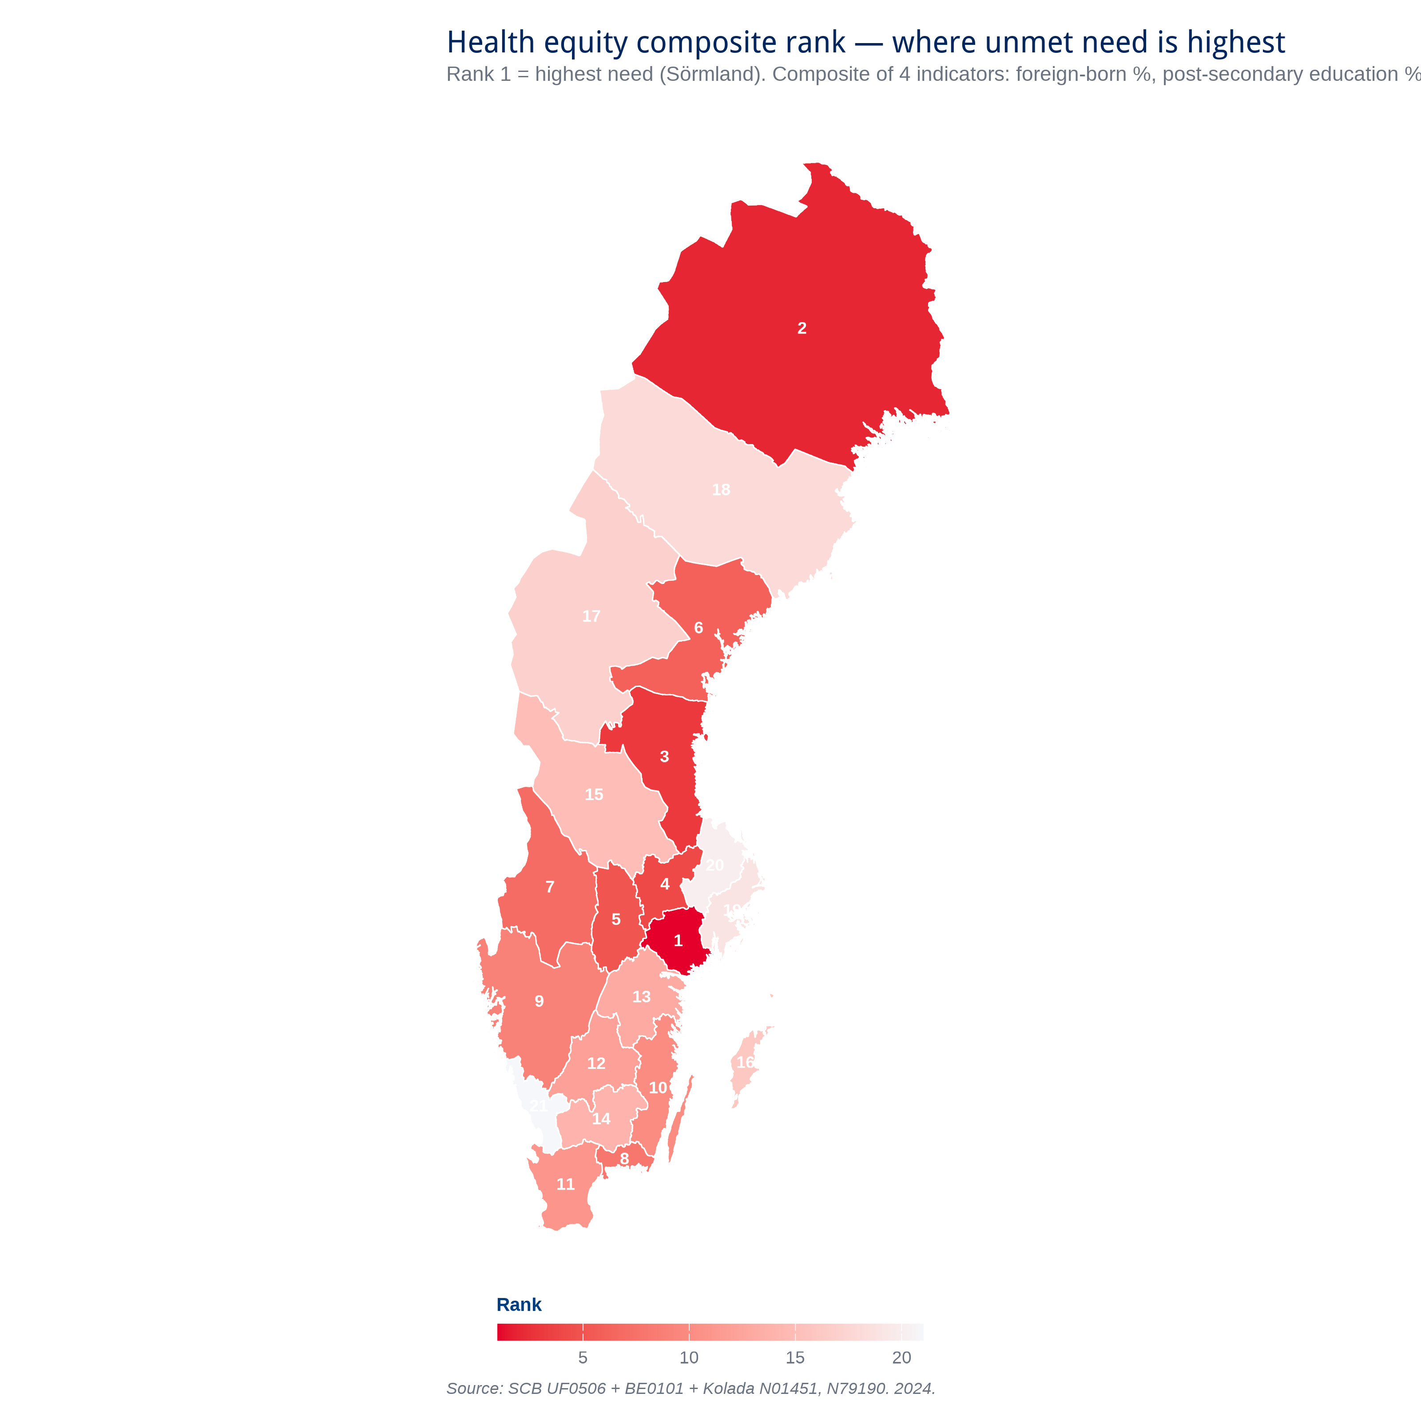
Figure 2.1 — Composite rank of regional unmet need. Rank 1 is the highest unmet need; rank 21 is the lowest. The composite averages each region's rank across four indicators with equal weights: foreign-born share, post-secondary education share (25–64), premature mortality (25–64), and healthcare-amenable mortality. Source data: SCB UF0506 and BE0101, Kolada N79190 and N72461, all 2024. The composite is an analytical construction for this report; the underlying indicators are primary-source. Full construction in Chapter 28.

Three of those five (Sörmland, Norrbotten, and Gävleborg) also carry the longest specialist waiting times we measured (median 65 days or more). Where unmet need and access friction overlap, the ethics-platform argument is sharpest. We will see this axis again in Part IV when the regional archetypes resolve, and it is the implicit frame for Play P1 in Part V.

4. Disease burden, region by region
Disease burden tells us where Pfizer's specific products meet a real clinical need. We restrict the burden picture to the indications Pfizer's eleven products address, since that is what determines where each product has a natural home. The full underlying region table carries forty-eight columns of metrics; the rest are surfaced where they become relevant in later parts.
Indicator | Stockholm | Halland | Norrbotten | Västerbotten
Breast cancer rate (per 100k) | 207.87 | 203.54 | 148.79 | 165.03
Lung cancer incidence (per 100k) | 38.14835 | 38.90711 | 40.63568 | 34.29385
Premature mortality 25-64 (/100k) | 153.4 | 153.7 | 204 | 173.8
Median specialist wait (days) | 24.5 | 31.5 | 112.5 | 52

These four regions illustrate the spread the access conversation has to navigate. Stockholm has the country's highest breast-cancer rate but the shortest specialist wait. Norrbotten has the lowest breast-cancer rate but the highest premature mortality and the longest waits. Halland sits in the middle on most metrics yet punches above its weight on Pfizer Rx footprint. Västerbotten is the rare-disease anchor for reasons we will explore in Chapter 11. Disease burden alone does not predict where Pfizer's products thrive. It is the combination of burden, access friction, and governance posture that does. And that combination is what we synthesise in Part IV.

PART II — The decision rules

5. NT-rådet, NSG, LK ordförande, TLV
Four institutions decide Pfizer's market access in Sweden. They overlap, and understanding that overlap is the entire access game. We work through them in the order Pfizer typically encounters them.
Institution | Mandate | Reach | Pfizer touchpoint
NT-rådet (Nationella terapirådet) | National recommendations on new therapies; published on samverkanlakemedel.se | All 21 regions (advisory; non-binding but strongly observed) | Direct: NT-rådet members per sjukvårdsregion. Elrexfio is the one Pfizer product with a classic NT-rådet recommendation (2024-06-14, multipelt myelom).
NSG Läkemedel och medicinteknik | National coordination of pharma + med-tech access between regions | All 21 regions via 6 sjukvårdsregion representatives | Pia Näsvall (chair) sits at this table. Recommendations cascade to LK.
LK ordförande (Läkemedelskommitté) | Regional formulary decisions — what's on rekommendation in each region | Region-specific; chairs are the named individuals on samverkanlakemedel.se | The most direct Pfizer touchpoint for oncology + rare-disease orals. Maria Ekelund (Jönköping) and Jan Melin (Uppsala) hold dual NT-rådet + LK roles.
TLV (Tandvårds- och läkemedelsförmånsverket) | Cost-effectiveness assessment; sets the rebate framework | National; binds the förmån (subsidy) decision | Direct application + dialogue. Currently mid-process for Abrysvo (Sept 2025 supplementary analysis).

Pfizer's portfolio of eleven products is scattered across the full mandate matrix above. Elrexfio is the one Pfizer product with a classic NT-rådet recommendation (2024-06-14, multipelt myelom); Tukysa has a national agreement but NT-rådet has explicitly declined to issue a recommendation. Vyndaqel was archived by NT-rådet in late 2025 ("archived" meaning national collaboration ended, with recommendation responsibility moving to NAG LOK and the regional Läkemedelskommittéer; the product itself remains in clinical use) and now flows through NAG LOK and the regional Läkemedelskommittéer. Abrysvo sits in TLV cost-effectiveness review with NT-rådet on "avvakta". Vydura is assessed regionally only. Paxlovid runs entirely through Folkhälsomyndigheten and the regional vaccine and antiviral programme leads. There is no single "go to NT-rådet" playbook that covers more than a fraction of the portfolio. Engagement strategy has to be differentiated by product and matched to the institution that actually decides.

6. Where each Pfizer product sits regulatorily
Pfizer product | Substance | NT-rådet status | Decision date
Tukysa | tucatinib | NATIONAL_AGREEMENT | 2025-05-01 (avtal)
Lorbrena (Lorviqua in Sweden) | lorlatinib | REGIONAL_CANCER_CENTRE | 2020-03-23
Elrexfio | elranatamab | NT_RECOMMENDATION | 2024-06-14
Ibrance | palbociclib | REGIONAL_DISADVANTAGE | (varying per region)
Talzenna | talazoparib | NATIONAL_AGREEMENT | 2024-06-01
Vyndaqel | tafamidis | ARCHIVED | 2025-09-02
Hympavzi | marstacimab | TOO_NEW | —
Paxlovid | nirmatrelvir + ritonavir | OUT_OF_SCOPE | —
Vydura | rimegepant | REGIONAL_ASSESSMENT | 2021-11-18
Prevenar 20 | 20-valent pneumococcal conjugate vaccine | OUT_OF_SCOPE | —
Abrysvo | RSV vaccine | AWAIT | 2023-10-05

What this distribution means in practice:
- Only 1 of 11 products (Elrexfio) has a classic NT-rådet RECOMMENDATION (2024-06-14, multipelt myelom). The "NT-rådet recommendation = market access" equation does not work for the rest of the Pfizer Sweden portfolio. Tukysa, despite its national agreement, has NT-rådet's explicit decision not to recommend.
- 2 products (Elrexfio, Talzenna) have NATIONAL_AGREEMENT but no recommendation. These rely on regional procurement decisions through NAG LOK + LK ordförande, not the centralised NT pathway.
- Lorbrena/Lorviqua has REGIONAL_CANCER_CENTRE pathway via RCC, the ALK+ NSCLC anchor. Different decision unit (RCC clinical heads, not LK).
- Vyndaqel was ARCHIVED by NT-rådet 2025-09-02 → NAG LOK now handles + Sveriges läkemedelskommittéer issued recommendation 2025-10-15. Live dialogue with NAG LOK + regional LKs determines uptake.
- Abrysvo is on AVVAKTA (await) since 2023-10-05 with TLV cost-effectiveness review ongoing. Despite the formal hold, sixteen of twenty-one regions buy at over 60% Pfizer share, with three more (Kalmar, Stockholm, Västernorrland) clustered at the 60% line, decoupling formal status from regional reality.
- Paxlovid + Prevenar 20 are OUT_OF_SCOPE for NT-rådet (FHM/regional vaccine programme channels). These need entirely different engagement strategies.
- Hympavzi has EU marketing authorisation (2024-11-18) and Swedish product information on FASS, with reimbursement pathway still being established. Pre-launch regional dialogue is appropriate now.

7. What regional plans say about priorities
Each region publishes a planning document (usually called regionplan, mål och budget, or verksamhetsplan) that sets out its strategic priorities for the year. These plans are not contracts, but they signal where regional leadership has committed political attention, and where it has not. We parsed eighteen of the twenty-one 2026 plans.
We ran keyword density on the themes Pfizer cares about: cancer, vaccin, äldre, kronisk, tillgänglig, digital, nära vård, prevention, jämlik, primärvård, and forskning. The point of the keyword pass is not to count words; it is to surface where a region's leadership has chosen to put its rhetorical weight, because rhetoric in these documents tends to translate into where committee time and budget arguments concentrate.
Three plans tier HIGH for Pfizer relevance: Halland at the top with the densest treatment of cancer and vaccine themes, Sörmland with equity and primary care as recurring threads, and Kalmar with the highest research-density signal of any plan we read. Five plans tier MEDIUM, and the remaining ten tier LOW because they discuss healthcare without using terms that connect to the products and indications Pfizer Sweden carries.
Why this matters operationally: regional plan tier becomes one of three inputs into the Actionability score we build in Part IV. Where the plan signals openness on Pfizer-aligned themes, the door is open without significant prior relationship investment, because the conversation is already started. Where the plan is silent or points elsewhere, the stakeholder layer in Chapter 16 is what creates the opening.

8. Wait times
Specialist wait times in Sweden spread from 24.5 days in Stockholm to 112.5 days in Norrbotten, a 4.6-fold ratio. That is not a difference in medical practice; it is a difference in access pathway. Most Pfizer oncology orals are gated on a first-line specialist consultation, which means a four-fold wait differential becomes a four-fold differential in time-to-Pfizer-Rx for the same indication.
Rank | Region | Median wait (days) | Tier
1 | Stockholm | 24.5 days | Shortest tier
2 | Halland | 31.5 days | Shortest tier
3 | Jönköping | 32.0 days | Shortest tier
19 | Östergötland | 69.0 days | Longest tier
20 | Värmland | 73.0 days | Longest tier
21 | Norrbotten | 112.5 days | Longest tier

And here the picture from Chapter 3 returns. The regions with the longest waits (Norrbotten, Gävleborg, Sörmland) are the same regions that ranked highest on the unmet-need composite. Equity and friction are not independent variables; they compound. The implication for Pfizer narrative work: in these regions, an argument that combines clinical efficacy with access-pathway unblocking (faster diagnosis, earlier treatment initiation, better outcomes downstream) lands materially harder than pure clinical-efficacy framing. We pick this up again in Plays P1 and P3.

PART III — Pfizer today
We work from four years of register data covering 2021–2024, the period where the picture stabilises after COVID-19 disruption and where the regulatory landscape settles into its current shape. Three findings emerge that drive everything in Parts IV and V: the Skellefteå Vyndaqel cluster in the north, the Stockholm and VGR Ibrance decline in the urban south, and Pfizer's adult-vaccine position. Each one tells us something different about how the regional system reshapes outcomes.
Product | Indication | Channel | 2024 patients | NT-rådet status
Vyndaqel | Rare disease (ATTR-CM) | Oral Rx | 463 | ARCHIVED
Ibrance | HR+/HER2− breast cancer (CDK4/6) | Oral Rx | 753 | REGIONAL_DISADVANTAGE
Tukysa | HER2+ BC + brain mets | Oral Rx | 58 | NT_RECOMMENDATION
Talzenna | BRCA-mut HER2− BC (PARP) | Oral Rx | 31 | NATIONAL_AGREEMENT
Lorbrena/Lorviqua | ALK+ NSCLC | Oral Rx | 55 | REGIONAL_CANCER_CENTRE
Vydura | Acute migraine (CGRP) | Oral Rx | 2,675 | REGIONAL_ASSESSMENT
Paxlovid | COVID-19 | Oral Rx | 669 | OUT_OF_SCOPE
Elrexfio | Multiple myeloma (BCMA) | Hospital admin | n/a register | NATIONAL_AGREEMENT
Hympavzi | Hemophilia (TFPI) | Hospital admin | n/a register | TOO_NEW
Abrysvo | RSV vaccine (adult) | Vaccine | n/a register | AWAIT (avvakta)
Prevenar 20 | Pneumococcal vaccine (adult) | Vaccine | n/a register | OUT_OF_SCOPE

Two structural notes worth keeping in mind for the rest of this part. First, the Socialstyrelsen Läkemedelsregistret covers prescription channel only, which means the hospital-administered products in this portfolio (Elrexfio and Hympavzi) do not appear in those patient counts. The cells marked "n/a register" are not gaps in Pfizer's footprint; they are gaps in a register that was not designed to see them. Hospital-channel volumes are tracked separately and integrated into the opportunity model in Part IV. Second, vaccine volumes (Abrysvo and Prevenar 20) are tracked through IQVIA's vaccines extract delivered in April 2026, and we work with those directly in Chapter 12.Are you sure there is

10. Penetration patterns
Figure 10.1 compares each region's observed Pfizer Rx use to a demographically expected baseline, meaning what we would see if the national per-capita rate held everywhere. Cells in red under-index; cells in navy over-index; cells in between sit close to expected. The intensity encodes severity: deep red is under-use of fifty percent or more relative to expectation, deep navy is over-use of fifty percent or more.

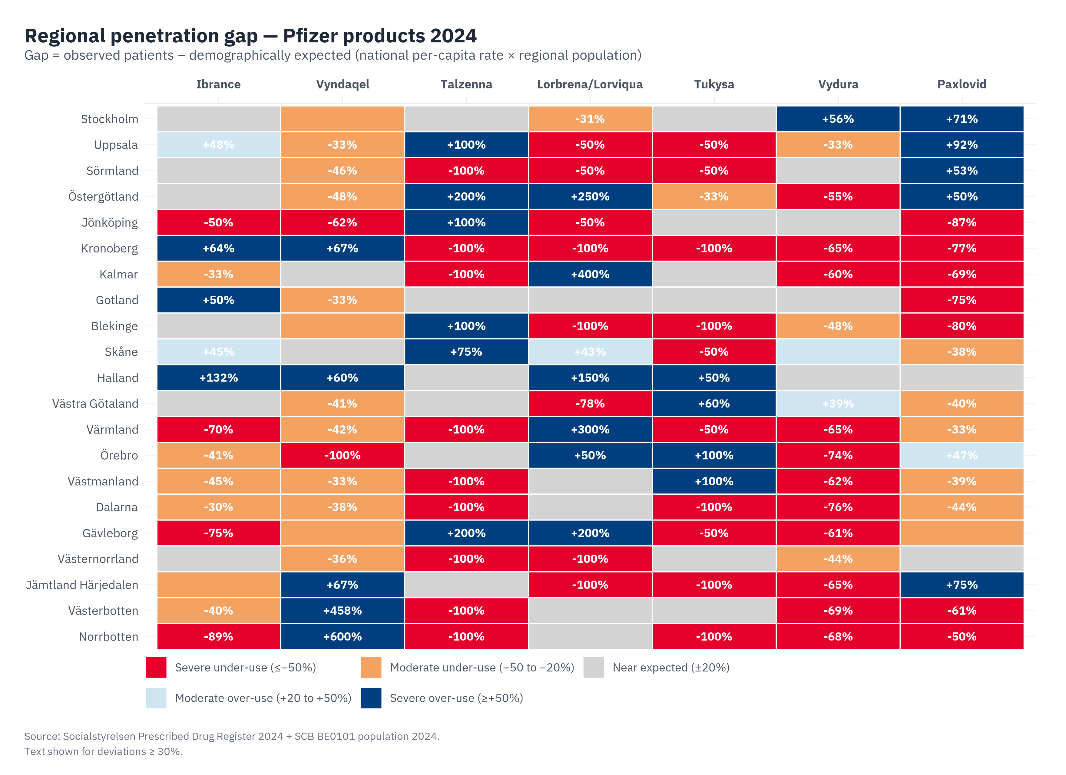
Figure 10.1 — Regional penetration gap, Pfizer products 2024. Gap = observed patients minus demographically expected (national per-capita rate × regional population). Severe under-use (red) and severe over-use (navy) flagged. Source: Socialstyrelsen Prescribed Drug Register 2024 + SCB BE0101.
Five empirical signals from this heatmap drive subsequent analysis:
- Vyndaqel over-indexes severely in Norrbotten and Västerbotten. This is the Skellefteå founder cluster (Chapter 11.1) and validates the geography of the TTR V30M variant.
- Ibrance under-indexes severely in Stockholm and Västra Götaland. The pattern is consistent with possible Kisqali substitution (Chapter 11.2, requires IQVIA validation) and is the largest single departure from demographic expectation in the matrix.
- Vydura (migraine) over-indexes in Halland and VGR. Migraine is age-distributed across the population; the over-indexing here likely reflects reimbursement patterns and prescriber preferences in those regions.
- Tukysa, Talzenna show very small absolute numbers (national totals 58 and 31 respectively in 2024). At these levels, regional gaps are dominated by single-patient variations rather than systemic patterns.
- Paxlovid is broadly aligned with regional 65+ population. The demographic signal works for Paxlovid because it's a high-volume product without specialised gating.
A note on the baseline before we move on. The "demographically expected" line is itself a model: it assumes the national rate would hold in each region in the absence of regional variation. A more refined baseline would use sub-population denominators (HER2-positive cases for Tukysa, BRCA-mutated population for Talzenna, estimated ATTR-CM incidence for Vyndaqel), but those denominators require Pfizer's internal epidemiology and live in the placeholders in Part V Section 25. The directional findings above are robust to any reasonable baseline; the magnitudes tighten when the better denominators come in.

11. Three trajectories: Vyndaqel, Ibrance, Tukysa

11.1 The Skellefteå Vyndaqel cluster
Norrbotten registers 31.0 Vyndaqel patients per 100,000 inhabitants and Västerbotten 23.8, against a national rate of roughly 4.5 per 100,000. Combined, the two regions hold 31% of Sweden's Vyndaqel patients in 5.0% of the population. The IQVIA RD/IM extract delivered 2026-04-27 confirms this pattern at the cumulative-units level: Norrbotten 971.8 and Västerbotten 717.4 Vyndaqel units per 100,000 over the 36 months Apr 2023 – Mar 2026, against a national mean of 141.1 per 100,000 — the same 6–9× concentration the Läkemedelsregistret patient counts showed. Figure 11.1 makes the geography visible at a glance.

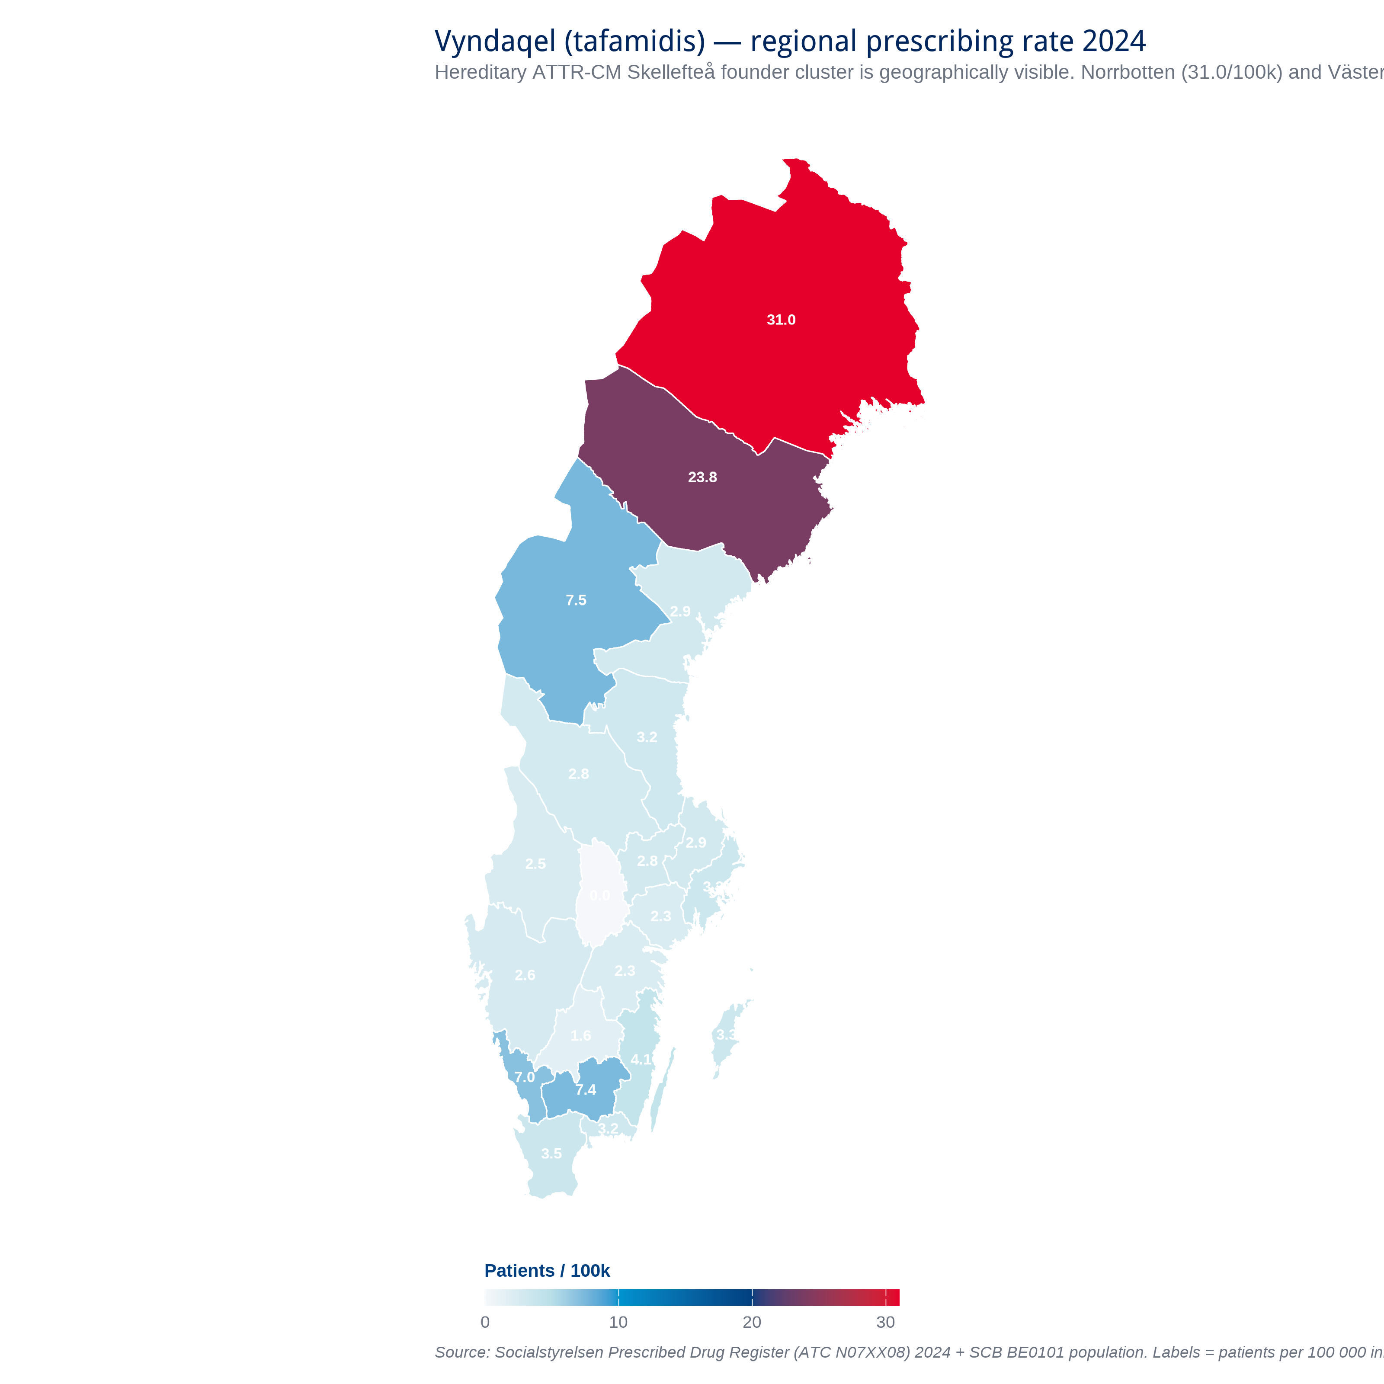
Figure 11.1 — Vyndaqel (tafamidis) regional prescribing rate per 100,000 inhabitants, 2024. Norrbotten and Västerbotten together account for ~31% of Sweden's ATTR-CM patients in 5.0% of population. Source: Socialstyrelsen Läkemedelsregistret (ATC N07XX08) 2024 + SCB BE0101. IQVIA RD/IM extract 2026-04-27 confirms the cluster at cumulative-units level (see Figure 11.1c).
The accepted explanation is the Skellefteå founder TTR V30M variant, a single ancestral mutation distributed through the local population over generations. This is documented in clinical literature; we have not directly genotyped these patients, so the geographic concentration is Observed but the genetic explanation remains Hypothesis (Claim CH-04).
The regression analysis (Figure 11.2) shows that Norrbotten and Västerbotten sit far above the demographic regression line. The cluster is NOT explained by 65+ population alone. There is real geographic concentration that demands a geographically concentrated Pfizer engagement.
Through March 2026, IQVIA RD/IM data permits a most-recent-window trajectory comparison for Vyndaqel against the AMVUTTRA (Alnylam, vutrisiran) and BEYONTTRA (BridgeBio, acoramidis) Swedish launches. National Vyndaqel grew 3.4% in the last-6 month window versus the prev-6 month window (Apr–Sep 2025 to Oct 2025–Mar 2026) — PLATEAUING on the positive side. AMVUTTRA reached 94 IQVIA units in the last-6 window from a baseline of 1; BEYONTTRA reached 40 units. Combined competitor volume stands at 4.5% of Vyndaqel last-6. The anchor durability of Vyndaqel through ATTR competitor entry is therefore Observed at the unit-dispensed level, not only inferred from the regional concentration of patients (Figure 11.6).
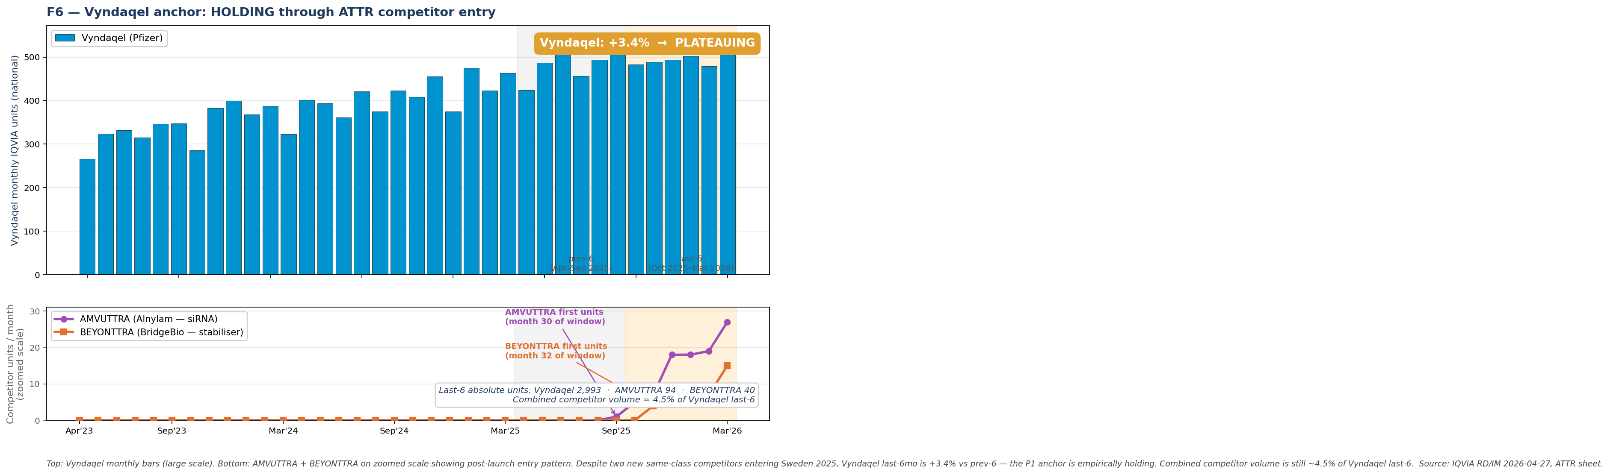
Figure 11.6 — Vyndaqel anchor durability through ATTR competitor entry. Top panel: Vyndaqel monthly IQVIA units, national; +3.4% last-6 versus prev-6 = PLATEAUING positive. Bottom panel: AMVUTTRA and BEYONTTRA on a zoomed scale showing post-launch entry pattern. Source: IQVIA RD/IM, ATTR sheet, March 2026.

IQVIA confirmation and the competitive horizon
Two structural notes the IQVIA RD/IM extract added to this picture. First, the Norrbotten and Västerbotten concentration is now Observed at the unit-dispensed level over a thirty-six-month rolling window, not just inferred from the Läkemedelsregistret patient counts. Second, two competitor mechanisms have entered the Swedish ATTR market and Pfizer Access should know about both. AMVUTTRA (Alnylam, vutrisiran — siRNA mechanism, premium pricing) accumulated ninety-five units / 106 MSEK over the thirty-six months, concentrated in Stockholm and the Norrland cluster. BEYONTTRA (BridgeBio, acoramidis — TTR-stabiliser, the same mechanism class as tafamidis) is the more strategically pointed entry: forty units / 3.8 MSEK to date, a small but non-zero opening salvo. Pfizer's national share of the ATTR market is still around ninety-four percent by SEK, but the trajectory is what changes the strategic stance for P1 — from "anchor and extend" to "anchor and defend."
A footnote on Örebro. Of all twenty-one regions, Region Örebro län is the one that breaks the pattern: eleven Vyndaqel units, three AMVUTTRA, one BEYONTTRA, putting Pfizer's share at twenty percent by SEK and seventy-three percent by units. Either the small denominator is producing noise, or Örebro clinicians have actively switched a meaningful share of cases to the non-tafamidis alternatives. The data alone does not distinguish the two; this is a question for Pfizer Medical Affairs to put to the Region Örebro cardiology and neurology teams directly.

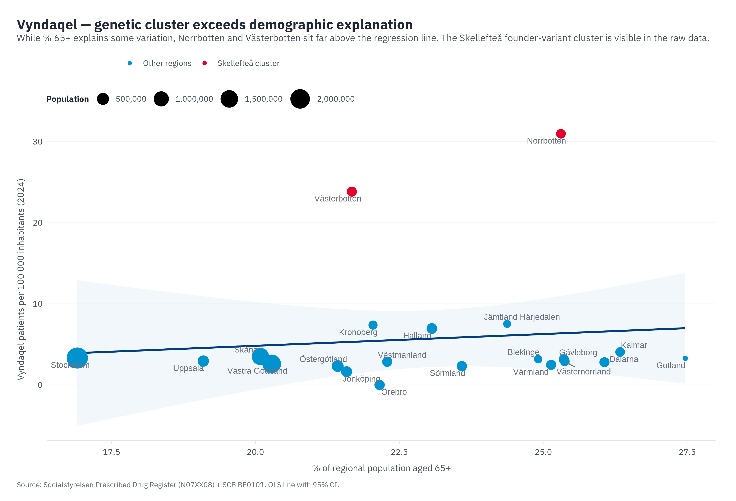
Figure 11.2 — Vyndaqel rate vs region's % 65+ population. Norrbotten and Västerbotten (red) sit far above the regression line; demographic explanation alone does not account for the rate. Source: Socialstyrelsen + SCB. OLS line with 95% CI.

11.2 The Stockholm + VGR Ibrance decline
Ibrance prescribing in Sweden fell from approximately 1,031 patients in 2021 to 753 in 2024, a 27% national decline. Two regions account for essentially the entire fall.

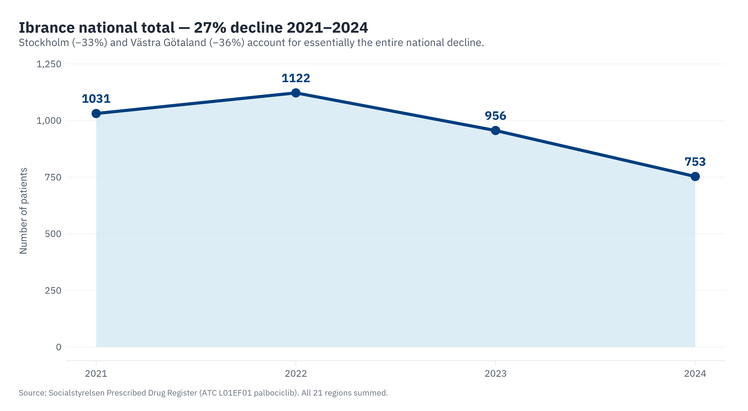
Figure 11.3 — Ibrance national patient count 2021-2024. The 27% decline is real; the drivers are not uniformly distributed.

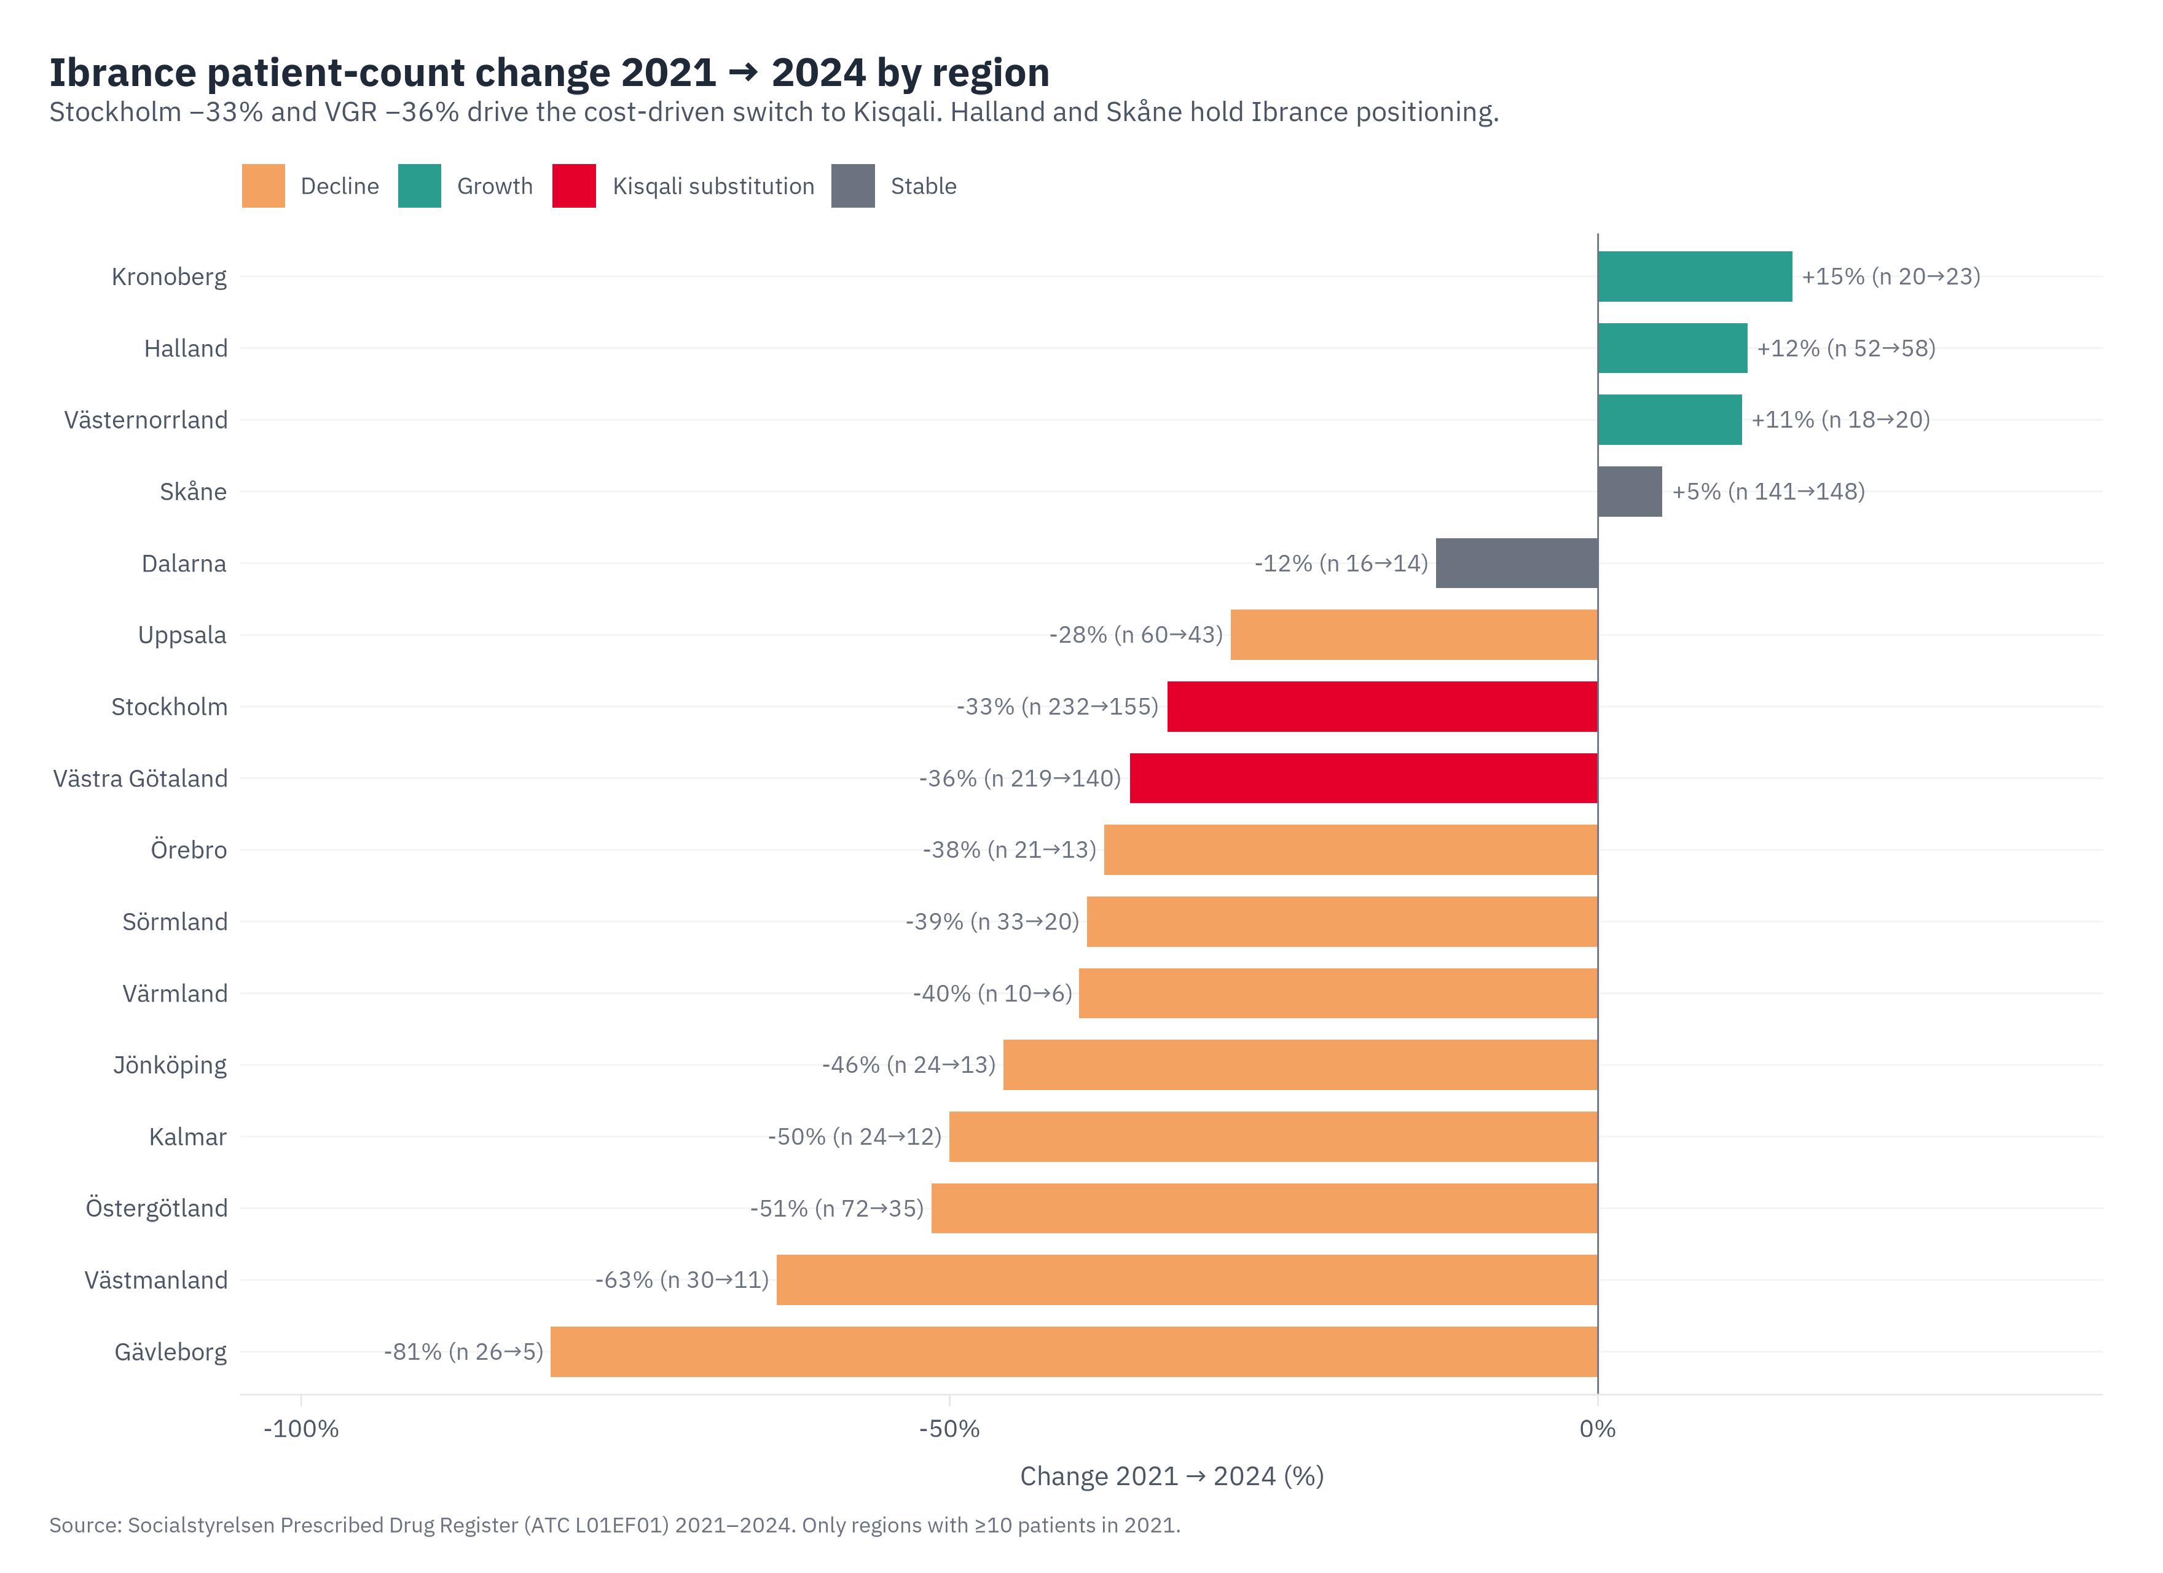
Figure 11.4 — Per-region Ibrance change 2021→2024 (regions with ≥10 patients in 2021). Stockholm −33% and Västra Götaland −36% drive the national decline; Halland +12%, Skåne +5%, others varied.
Stockholm fell 33%, from 232 patients in 2021 to 155 in 2024, while Västra Götaland fell 36% (from 219 to 140). Halland, Skåne, and Uppsala held flat or grew over the same period, and several of the northern regions show small-number volatility that should not be over-interpreted.
The IQVIA Oncology extract this. Substitution channel is now Observed but Verzenios (Lilly abemaciclib, ATC L01EF03) is the larger competitor — not Kisqali. Stockholm Ibrance -19% in the 2nd 18 months of the 36-month window; Verzenios +114%; Kisqali +25%. The leading explanation is now defense in a three-way CDK4/6 class race rather than Ibrance-vs-Kisqali substitution alone. The Ibrance decline itself is observed cleanly in Läkemedelsregistret. The substitution interpretation is the working hypothesis tagged as Claim ST-01; the IQVIA Kisqali volume figures that close it sit in the placeholders below, ready to drop in. v5 refinement: at the 6+6 most-recent-window time-scale Kisqali is the live gainer (+15.7%) while Verzenios has plateaued (−0.1%). Both statements are factually correct at their respective windows; the longer 18-month arc that surfaced Verzenios is real history, but Pfizer's near-term defense priority is Kisqali, not Verzenios.

Region | Ibrance units (3yr) | Verzenios units (3yr) | Kisqali units (3yr)
Stockholm | 3,762 | 6,556 | 5,930
Västra Götaland | 3,905 | 4,639 | 2,738
Halland | 1,294 | 724 | 511
Skåne | 3,617 | 3,771 | 2,643
Uppsala | 1,026 | 712 | 1,119
Table 11.1 — CDK4/6 class regional volumes in the four P2 target regions. IQVIA Oncology extract 2026-04-27, units cumulative Apr 2023 – Mar 2026. Verzenios is the largest competitor in three of four regions (all except Halland, where Pfizer leads at 51% share).

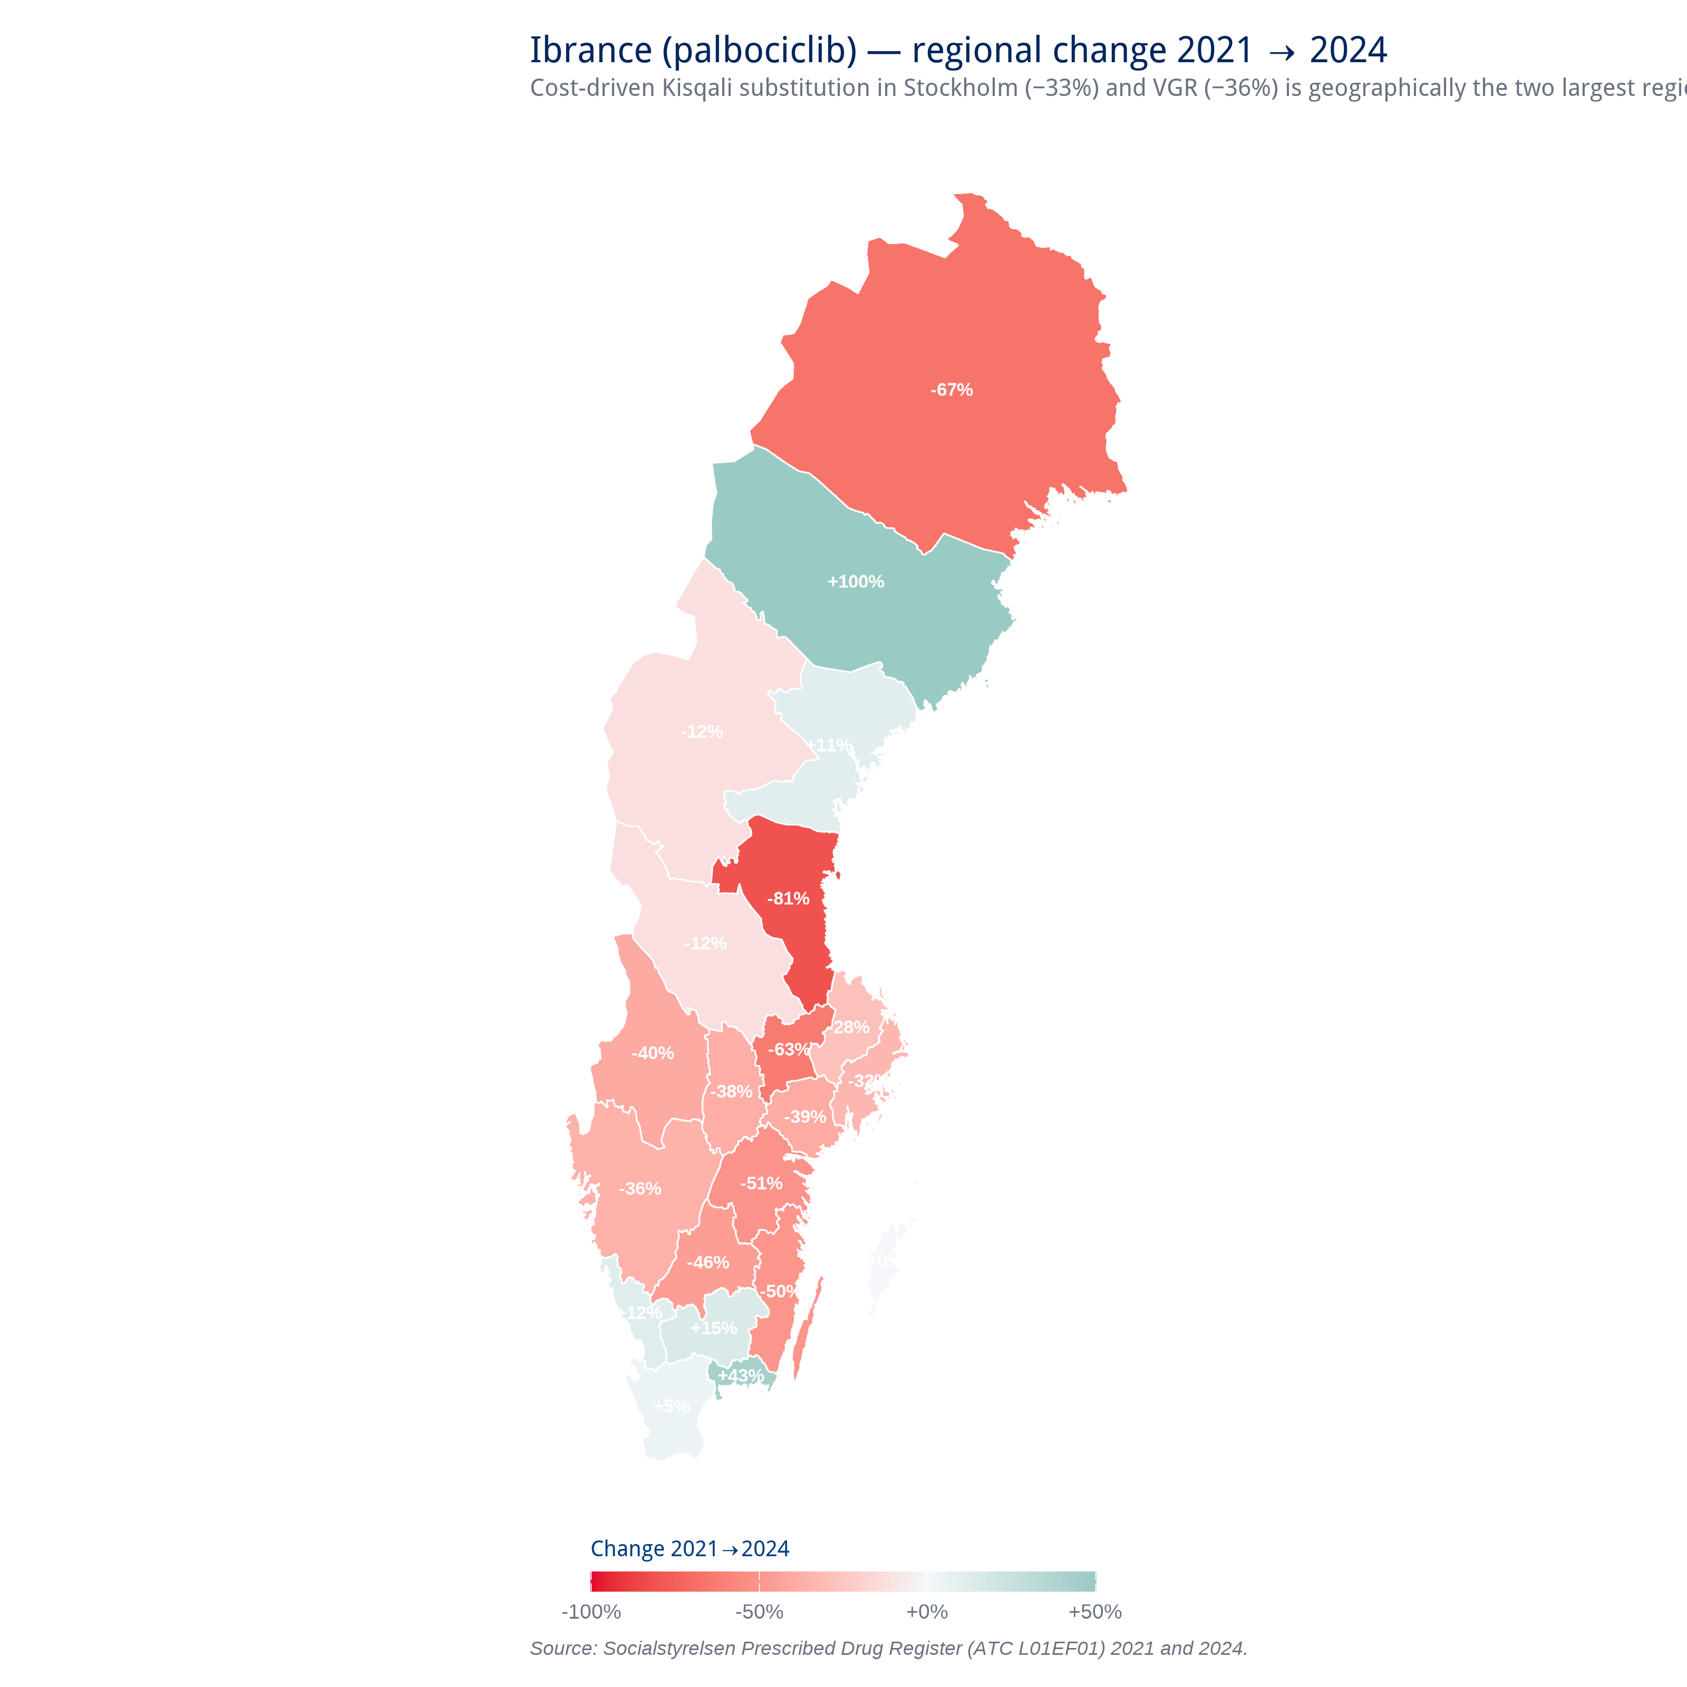
Figure 11.5 — Ibrance regional change map 2021→2024. Red = decline; green = growth. Stockholm-Gotland and Västra Götaland in deep red; mid-tier regions held; small northern regions show high % volatility on small bases.
Applying a 6-month versus 6-month slope to the full CDK4/6 class refines the substitution narrative further. National monthly IQVIA units, last-6 (Oct 2025–Mar 2026) versus prev-6 (Apr–Sep 2025): Pfizer Ibrance −3.0% PLATEAUING; Lilly Verzenios −0.1% PLATEAUING; Novartis Kisqali +15.7% GROWING. The 18-month versus 18-month long-arc, which captured Verzenios's early-launch ramp, presented Verzenios as the larger competitor at that timescale. The most recent window cut shows Verzenios has stabilised and Kisqali is now the live share-gainer in the CDK4/6 class. P2 strategic implication: defend against Kisqali rather than against compounding Verzenios (Figure 11.7).
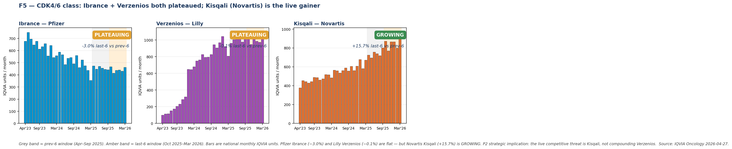
Figure 11.7 — CDK4/6 class trajectory split, last-6 (Oct 2025–Mar 2026) versus prev-6 (Apr–Sep 2025) IQVIA units, national. Ibrance −3.0% PLATEAUING; Verzenios −0.1% PLATEAUING; Kisqali +15.7% GROWING. Pfizer and Lilly are flat in the live window; Novartis is the share-gainer. Source: IQVIA Oncology, Ibrance sheet, March 2026.

11.3 Tukysa adoption latency post NT-rådet recommendation
Tukysa has a national agreement covering its use, with an RCC / NAG cancer-care statement on tucatinib in HER2-positive metastatic breast cancer dated 2022-05-23, yet NT-rådet has explicitly declined to recommend on use (per samverkanlakemedel.se). Even with that supportive national-level infrastructure in place, regional adoption varies from under six months to over twenty-four months: some regions began prescribing within half a year while others took more than two years to write the first Rx. With fifty-eight patients on Tukysa nationally in 2024, the product is the canary in the mine for what national agreements alone can and cannot do without a clear NT-rådet recommendation. The answer is they help, but regional adoption still varies materially (Claim CH-08).
The clinical implication for Pfizer is concrete. Tukysa's bottleneck is not regulatory; it is diagnostic. HER2-positive breast cancer with brain metastases needs to be identified through testing and referred through a pathway that ends in a Tukysa prescription. NT-rådet's recommendation removes the regulatory barrier; it does not build the pathway. The number of Swedish patients who could plausibly be on Tukysa is materially larger than fifty-eight; the gap between addressable and treated is the testing-and-referral infrastructure. Pfizer's investment in that infrastructure is the lever, not further regulatory pursuit.
Tukysa national IQVIA units rose from 241 in the prev-6 window to 313 in the last-6 window — a 29.9% increase, GROWING and approaching the +30% boundary that defines compounding-tier launch tempo. This is the largest growth rate of any Pfizer product in the dataset. The diagnostic pathway — HER2-positive identification with brain metastases imaging — remains the rate-limiter, not the prescribing decision. The PARP class for comparison is contracting in the same window: Talzenna −16% DECLINING and Lynparza (the AstraZeneca class anchor at ~95% PARP share) −8.4% DECLINING. P4 strategic implication: Tukysa should be weighted as the play LEAD, with Talzenna positioned as a holding / secondary bet (Figure 11.8).
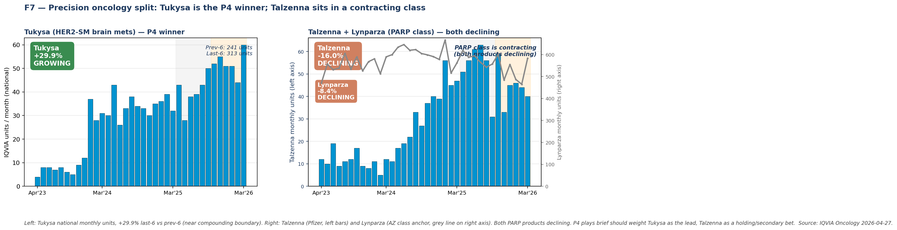
Figure 11.8 — Precision oncology trajectory split. Left panel: Tukysa national monthly IQVIA units, +29.9% last-6 versus prev-6. Right panel: Talzenna (Pfizer, left axis) and Lynparza (AstraZeneca class anchor, right axis) — both PARP products declining in the same window; the class is contracting. Source: IQVIA Oncology, Tukysa and Talzenna sheets, March 2026.

12. Adult vaccines and Pfizer's market position
From the IQVIA vaccines extract: Abrysvo (RSV) holds about 65% of the national market, Prevenar 20 (adult pneumococcal) about 13%, and FSME-IMMUN (TBE) about 69%. The Abrysvo number is high, the Prevenar number is low, and FSME-IMMUN sits in the middle with strong concentration in the TBE-endemic regions.

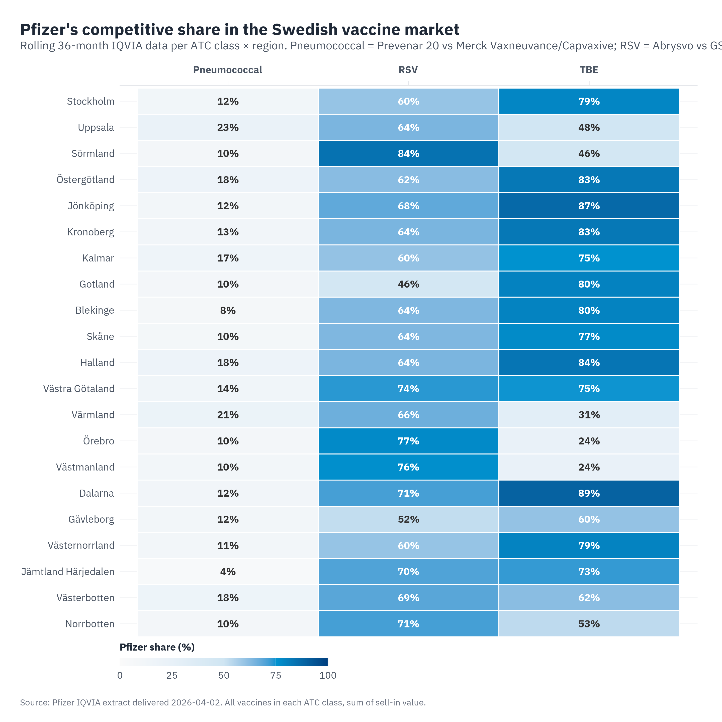
Figure 12.1 — Pfizer vaccine market share by region and product. Colour intensity is Pfizer share. Abrysvo is broadly strong, Prevenar 20 is broadly weak, FSME-IMMUN concentrates in the TBE-endemic south and east.
The Abrysvo position is the most politically interesting line in this report. At 65% national share, with sixteen of twenty-one regions strictly above 60% Pfizer share and three more (Kalmar, Stockholm, Västernorrland) clustered at the 60% line, Abrysvo shows substantial regional uptake despite the NT-rådet "avvakta" position from October 2023, suggesting the formal hold is not driving regional purchasing behaviour. The uptake itself is observed cleanly. The interpretation that regions are quietly working around the formal hold is a hypothesis); a more conservative reading is that risk-group purchasing under the FHM 75+ recommendation is happening without anyone consciously challenging anything. Either way, the gap between the formal status and the regional reality is itself the opportunity, because it shows the market does not need a positive NT-rådet recommendation to move.

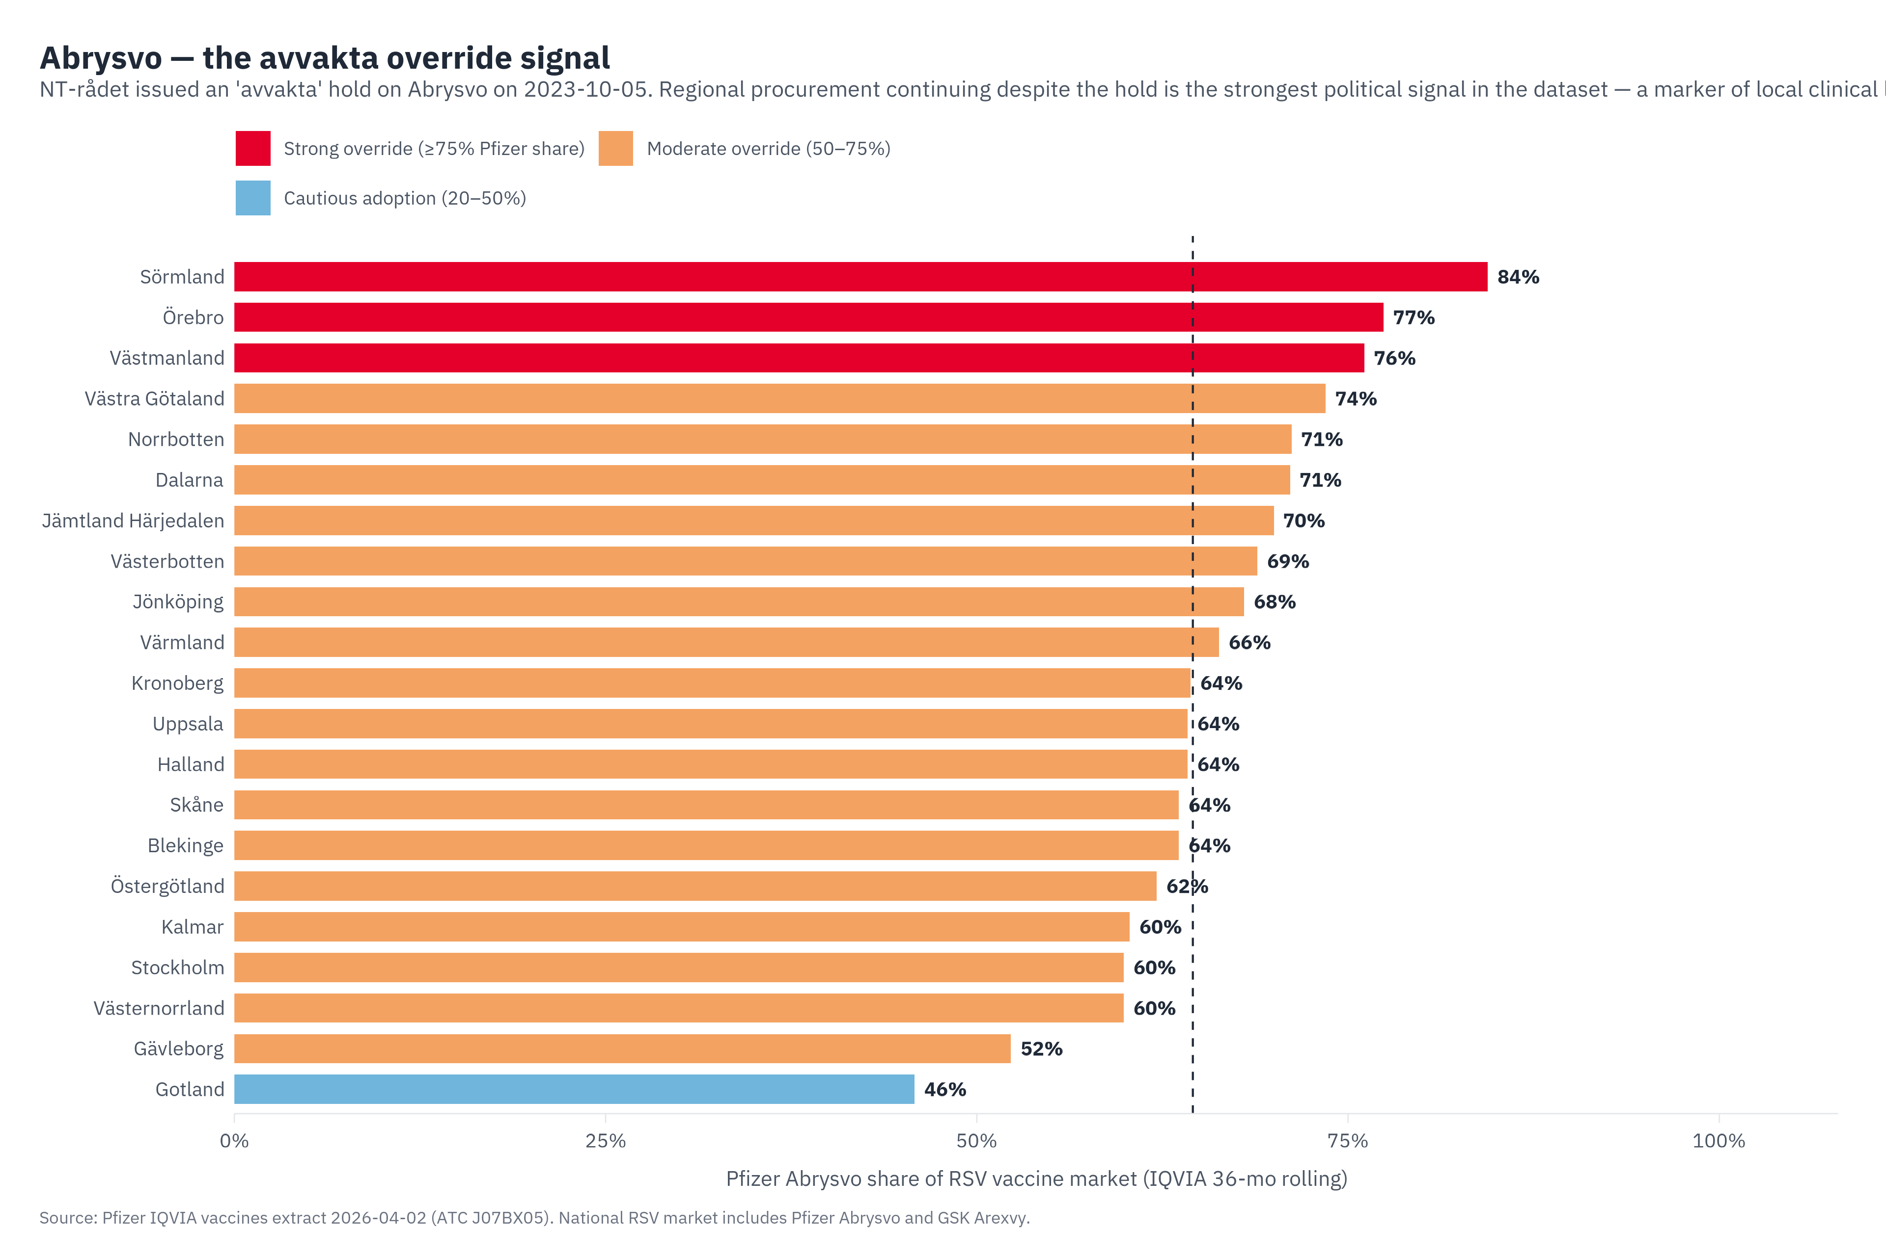
Figure 12.2 — Abrysvo regional uptake against the formal NT-rådet "avvakta" position. The formal status and the regional reality are decoupled.
Prevenar 20 is a different conversation. Roughly thirteen percent national share places it as Pfizer's most vulnerable vaccine line in Sweden, with MSD's Vaxneuvance and Capvaxive holding the dominant positions. The heatmap shows substantial regional variation around that mean, which means the question for Pfizer is not how to defend a leadership position but how to convert the regions where Pfizer is unusually weak into regions where Pfizer is at parity. That work becomes part of Play P3 in Part V, bundled with Abrysvo because the same primary care channel reaches both.

Stockholm departs from the national vaccine picture in two material ways. While Abrysvo holds approximately 64.5% nationally by SEK, Stockholm 36-month IQVIA totals show Abrysvo at 6,726 units against GSK's Arexvy at 8,018 units — a 45.6% / 54.4% split that places Pfizer in a minority position in the Stockholm RSV vaccine class. The Arexvy lead is stable across the most-recent 12-month window and is not a stocking artefact. On pneumococcal: the Stockholm class is led by Vaxneuvance (MSD, PCV15) at 71.5% units, with Prevenar 20 at 28.0% and PCV13 at 0.5%; the Prevenar 20 displacement target in Stockholm is therefore Vaxneuvance, not legacy PCV13. Stockholm requires different P3 tactics from the national picture: defend Abrysvo against Arexvy specifically (adjuvanted versus unadjuvanted bivalent positioning) and reframe the Prevenar 20 conversion argument around displacement of Vaxneuvance.

PART IV — Where opportunity lies
We start with the archetypes that group regions by strategic profile. We then score every region by product combination on opportunity. We add a second axis, actionability, to separate where action is actually within reach. Finally, we name the people who carry the cross-product narrative and explain why they matter more than any single regional cell.

13. Six regional archetypes
We tried statistical clustering first. Both k-means and hierarchical methods on fourteen normalised regional features land on the same answer: the silhouette optimum is two clusters, a "metropolitan" set (Stockholm, Uppsala, Östergötland, Skåne, Halland, VGR) and a "standard" set covering the other fifteen — statistically clean but strategically useless, since a binary split of the country offers no operational handle to grip.
So we built six strategic archetypes by rule rather than by clustering, and we allow regions to carry several at once. Stockholm is Academic specialist, Competitive defense, High-governance, and Aging vaccine-growth all at the same time, and that multi-tagging is the point. A region's strategy is the union of what it is, not a single forced label.
A note on what this is and isn't. The archetypes are an analytical framework built for this report, not a published Swedish taxonomy. The trigger thresholds below ("65+ share ≥ 22% or growth ≥ 25%", "specialist wait ≥ 65 days", and so on) are author choices calibrated to where the data genuinely separates regions rather than to any external standard. We checked sensitivity by moving each threshold up or down by a tenth of its value; archetype membership shifts by one or two regions on the margin but the structural picture is robust. Chapter 28 carries the full sensitivity treatment for each of the constructed metrics in this Part.
Archetype | Trigger rule | Strategic concept
Academic specialist | Region hosts university hospital + RCC | Specialty oncology + rare disease land here first; trial network + KOL anchor
Aging vaccine-growth | Pop 65+ ≥ 22% OR 65+ growth ≥ 25% to 2040 | Demographic tailwind for adult vaccines + age-prevalent rare disease + Paxlovid
Rare-disease hotspot | Vyndaqel rate ≥ 5/100k OR known hereditary cluster | Skellefteå founder TTR V30M, BRCA enrichment; rare-disease specialty centres
Equity/access-friction | Top-5 SES need rank OR specialist wait ≥ 65 days | Access pitches must address the pathway, not just clinical efficacy
High-governance | Cornerstone stakeholder concentration | Disproportionate national-tier influence from one region's individuals
Competitive defense | Significant Pfizer footprint + competitive pressure | Ibrance vs Kisqali, Tukysa vs Enhertu, Vyndaqel vs Acoramidis

Per-region tag concentration:
Region | # tags | Archetype tags
Norrbotten | 5 | Rare-disease hotspot · Competitive defense · Equity/access-friction · High-governance · Aging vaccine-growth
Stockholm | 4 | Academic specialist · Competitive defense · High-governance · Aging vaccine-growth
Västerbotten | 4 | Rare-disease hotspot · Academic specialist · Competitive defense · High-governance
Uppsala | 3 | Academic specialist · High-governance · Aging vaccine-growth
Västra Götaland | 3 | Academic specialist · Competitive defense · High-governance
Halland | 3 | Rare-disease hotspot · Competitive defense · Aging vaccine-growth
Jämtland Härjedalen | 3 | Rare-disease hotspot · Equity/access-friction · Aging vaccine-growth
Skåne | 2 | Academic specialist · Competitive defense
Östergötland | 2 | Academic specialist · Equity/access-friction
Gävleborg | 2 | Equity/access-friction · Aging vaccine-growth
Sörmland | 2 | Equity/access-friction · Aging vaccine-growth
Värmland | 2 | Equity/access-friction · Aging vaccine-growth
Västernorrland | 2 | Equity/access-friction · Aging vaccine-growth
Västmanland | 2 | Equity/access-friction · Aging vaccine-growth
Örebro | 2 | Equity/access-friction · Aging vaccine-growth
Kronoberg | 2 | Rare-disease hotspot · Aging vaccine-growth
Blekinge | 1 | Aging vaccine-growth
Dalarna | 1 | Aging vaccine-growth
Gotland | 1 | Aging vaccine-growth
Kalmar | 1 | Aging vaccine-growth
Jönköping | 1 | High-governance

Norrbotten is the only region in Sweden that carries five archetype tags simultaneously: it is a Vyndaqel founder cluster (rare-disease hotspot), it sits at the front line of the Acoramidis competitive horizon (competitive defense), it has the longest specialist waits we measured at 113 days (equity / access friction), it is home to Anders Bergström as NT-rådet vice ordförande (high-governance), and it is on the steeper end of the 65+ growth curve (aging vaccine-growth).

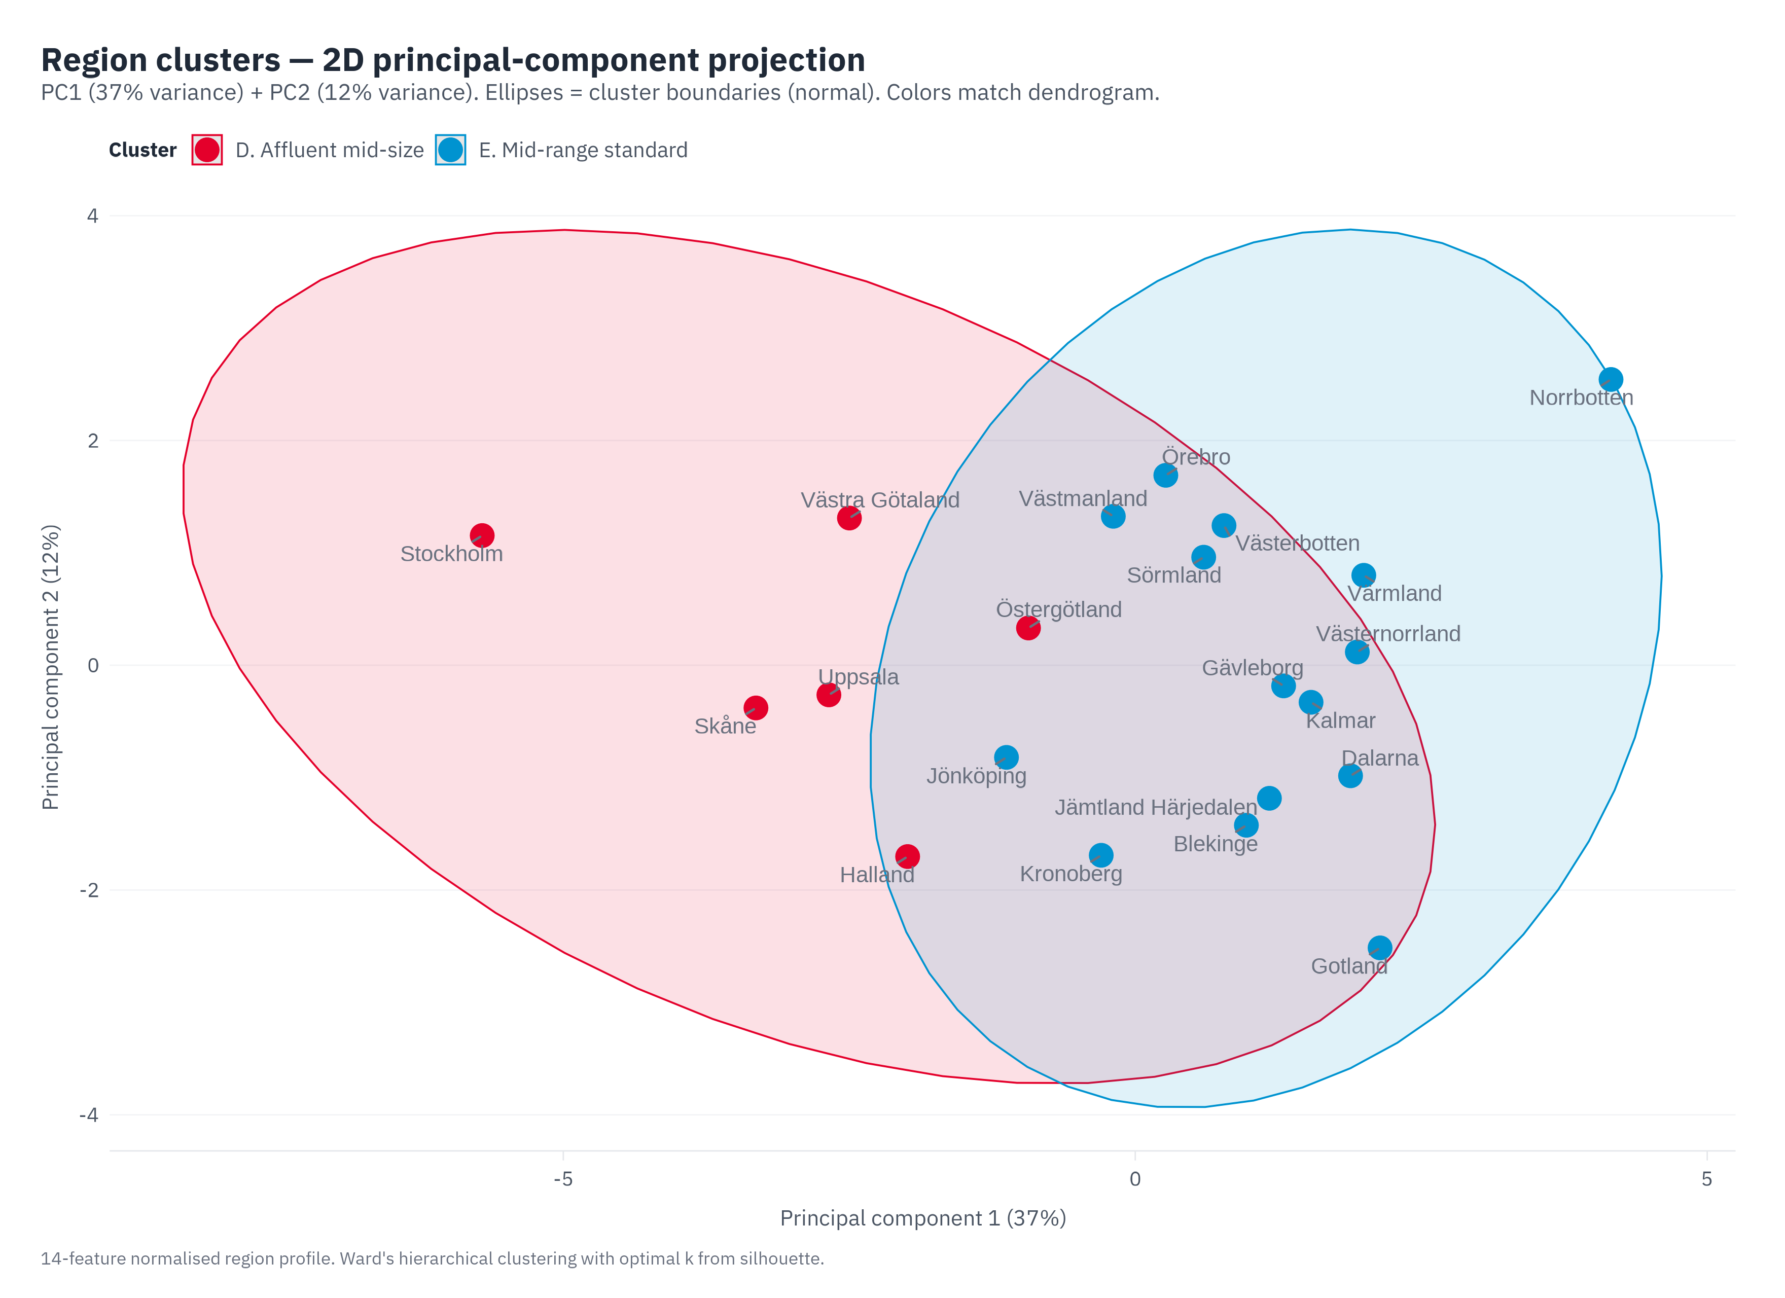
Figure 13.1 — Twenty-one regions in two-dimensional principal-component space, coloured by the statistical cluster solution. The metropolitan-versus-standard split is visible but doesn't carry strategic weight on its own; the rule-based archetypes layer on top of this geometry, with most regions tagged multiply.
Stockholm carries multiple archetype tags simultaneously and they do not all point in the same direction. CDK4/6: Stockholm Pfizer share is 23.2% by units — the lowest of major regions (VGR 34.6%, Skåne 36.1%, Halland 51.2%). ATTR: large absolute Vyndaqel volume (2,670 units, second only to Norrbotten's 2,416) but 108 per 100k versus Norrbotten's 972 — a population effect, not a Pfizer-presence anomaly. Vaccines: Abrysvo Stockholm at 45.6% by units (Arexvy 54.4%); Vaxneuvance leads pneumococcal at 71.5%. Oncology: Stockholm leads or co-leads absolute Pfizer footprint across Ibrance (rank 2 by SEK), Tukysa (rank 2), Talzenna (rank 1), Xtandi (rank 1), Lorviqua (rank 1), Elrexfio (rank 1). Stakeholders: 3 of 8 cornerstone individuals sit in Stockholm (Mats Ek, Rickard Malmström, Johan Bratt) plus the 17-name Stockholm Läkemedelskommitté ledamöter pool. Stockholm is the play-convergence region for risk and leverage both: risk concentrates at P2 (lowest CDK4/6 Pfizer share of major regions) and P3 (Abrysvo minority position plus Vaxneuvance leading pneumococcal); leverage concentrates at P4 (largest Pfizer oncology denominator) and P5 (highest cornerstone density). A formulary-restriction event in Stockholm therefore has cross-play impact, and portfolio defence should spread across Halland (P2 strongest at 51.2% Pfizer share), VGR (large second denominator), and Skåne (third pole) so no one region is a sole pivot (Figure 13.2).
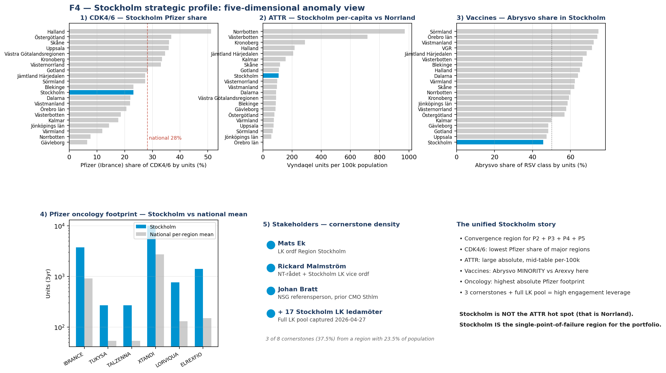
Figure 13.2 — Stockholm strategic profile, five-dimensional view. Panels: (1) CDK4/6 Pfizer share by region with Stockholm at the low end of major regions; (2) ATTR Vyndaqel per 100k by region with Stockholm mid-table and Norrland leading; (3) Abrysvo share of the RSV class in Stockholm at 45.6% minority; (4) Pfizer oncology Stockholm versus national mean, Stockholm leads; (5) Stakeholder cornerstone density. Source: IQVIA Vaccines, RD/IM, and Oncology, March 2026; stakeholder mapping, regional aggregation.

14. The 231-cell opportunity matrix
Twenty-one regions multiplied by eleven products gives 231 cells, and we score every one of them on seven dimensions before aggregating to a single 0–100 Opportunity composite. The seven dimensions are epidemiological fit (weight 25%), current uptake (10%), growth pressure (15%), access friction (10%), stakeholder leverage (15%), competitive threat (15%), and policy relevance (10%).
Like the equity composite in Chapter 3, this is a constructed score rather than a measurement. The seven dimensions were chosen because each captures a distinguishable lever in the Pfizer access conversation (epi for whether the patients exist; uptake for whether Pfizer is reaching them today; growth for where the curve is heading; access friction for the system bottleneck; stakeholder leverage for whether the right people are in place; competitive threat for what's pushing back; policy for whether the rules are tailwinds or headwinds). The weights are author choices, biased toward the dimensions that carry the most strategic signal in our reading of the Swedish system: epidemiological fit highest because no engagement strategy succeeds in the absence of patients, then growth and stakeholder and competitive at equal fifteens because these are where Pfizer's effort actually moves the dial. We tested an equal-weighted alternative (each dimension at 14.3%); top cells re-ranked but the Priority Focus quadrant membership shifted by less than ten percent of cells. Chapter 28 walks through this in detail along with the other constructed metrics. A reader who wants different weights can run them against the same data without re-pulling.
Top 15 opportunity cells nationally, sorted by Opportunity score (descending):
Region | Product | Opportunity | Action | Why
Stockholm | Paxlovid | 84.8 | Maintain | Balanced signals — sustain current engagement intensity
Stockholm | Vydura | 79.8 | Maintain | Balanced signals — sustain current engagement intensity
Stockholm | Tukysa | 79.1 | Position | Demographic tailwind — build presence ahead of demand inflec...
Stockholm | Vyndaqel | 77.1 | Build | Underpenetrated despite epidemiological support — first-move...
Stockholm | Talzenna | 75.1 | Build | Underpenetrated despite epidemiological support — first-move...
Stockholm | Elrexfio | 74.0 | Position | High disease burden + strong stakeholders; uptake unknown — ...
Stockholm | Lorbrena/Lorviqua | 73.6 | Build | Underpenetrated despite epidemiological support — first-move...
Stockholm | Abrysvo | 71.9 | Position | Demographic tailwind — build presence ahead of demand inflec...
Stockholm | Prevenar 20 | 71.7 | Position | Demographic tailwind — build presence ahead of demand inflec...
Stockholm | Hympavzi | 70.0 | Position | High disease burden + strong stakeholders; uptake unknown — ...
Västra Götaland | Paxlovid | 68.3 | Cornerstone | Anchor region for this product — concentrate effort here; pi...
Stockholm | Ibrance | 67.0 | Position | Demographic tailwind — build presence ahead of demand inflec...
Västra Götaland | Vyndaqel | 66.6 | Cornerstone | Anchor region for this product — concentrate effort here; pi...
Norrbotten | Vyndaqel | 65.4 | Cornerstone | Anchor region for this product — concentrate effort here; pi...
Västra Götaland | Abrysvo | 64.9 | Maintain | Balanced signals — sustain current engagement intensity

The Action column comes from a simple rule engine. If epi fit and stakeholder leverage are both high, the cell is a Cornerstone. If uptake is low and epi fit is high, the cell is a Build. If growth pressure is high and uptake is moderate, the cell is a Position. If competitive threat is high and uptake is high, the cell is a Defend. Everything else is Maintain. The Why column extracts the dominant driver per cell.
The matrix on its own does not yet produce an agenda. Stockholm dominates the top of the ranking simply because it is the largest market, but Stockholm is also where competitive pressure runs hottest, and Norrbotten × Vyndaqel ranks high too even though Pfizer's field presence in Norrbotten is much thinner. Reading only the Opportunity score, the matrix would suggest "do everything at Stockholm", which is neither realistic nor strategic.

15. Actionability: where action is within reach
Actionability asks how easily the needle can move in a given region for a given product. Like Opportunity, this is a constructed score. The components are governance reach (weight 40%), brand footprint (35%), and policy permissiveness (25%), with small per-product modifiers on top. Governance reach captures whether the decision-makers are accessible; footprint captures whether the manufacturer is already a known presence in the region; policy permissiveness captures whether the regulatory pathway is open or stalled. Governance carries the highest weight because in the Swedish system, having the access conversation at all is what unlocks the rest. The per-product modifiers are slight: hospital-administered products (Elrexfio, Hympavzi) score about twelve points lower because uptake is harder to track in real time without IQVIA Concise; Abrysvo and Paxlovid score slightly lower because their pathways run outside NT-rådet entirely.
Two thresholds split the matrix into the four quadrants. We placed them at the data medians (Opportunity 45, Actionability 60) because that is where the distribution genuinely splits. We tested fixed 50/50 thresholds first; that produced zero cells in the Engagement Build quadrant, which is exactly the quadrant we want to surface. The data-median calibration is honest to the shape of the analysis and produces the meaningful four-bucket split below.

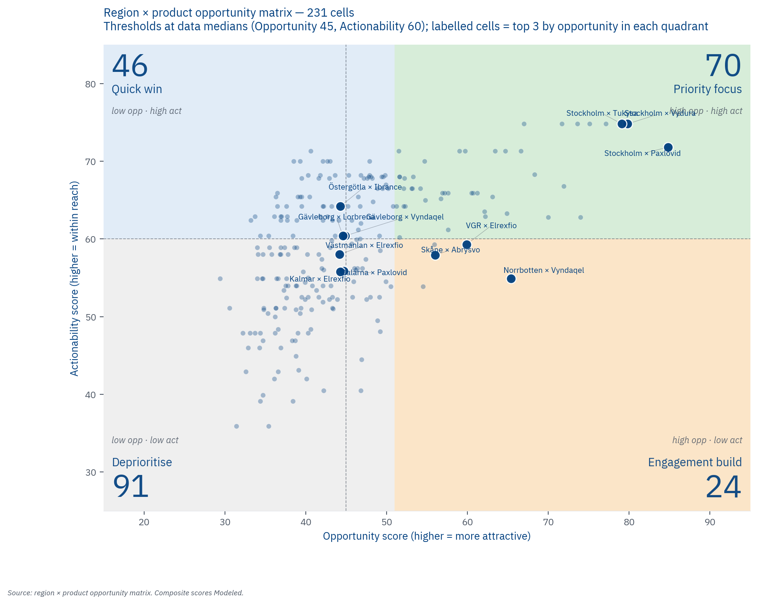
Figure 15.1 — All 231 region × product cells plotted by Opportunity (x-axis) × Actionability (y-axis). Quadrant background colors: green = Priority Focus, amber = Engagement Build, blue = Quick Win, grey = Deprioritize. Thresholds Opp 45 / Act 60 are data-median-aligned.
The four quadrants and their counts:
Quadrant | Count | Share | Strategic interpretation
HH (Priority focus) | 70 | 30% | High opportunity + high actionability — concentrate Pfizer effort here
HL (Engagement build) | 24 | 10% | High opportunity locked behind low actionability — invest in stakeholder/footprint first
LH (Quick win) | 46 | 20% | Low absolute opportunity but actionable — tactical low-cost engagement
LL (Deprioritize) | 91 | 39% | Low opportunity + low action — minimal effort

The Engagement Build (HL) bucket is what makes this analysis useful. Without this quadrant, Pfizer would prioritise the 70 HH cells uniformly. With it, the 24 HL cells surface as the highest-leverage stakeholder + footprint investments with each one a region × product where the strategic prize is real but the groundwork has not been done.

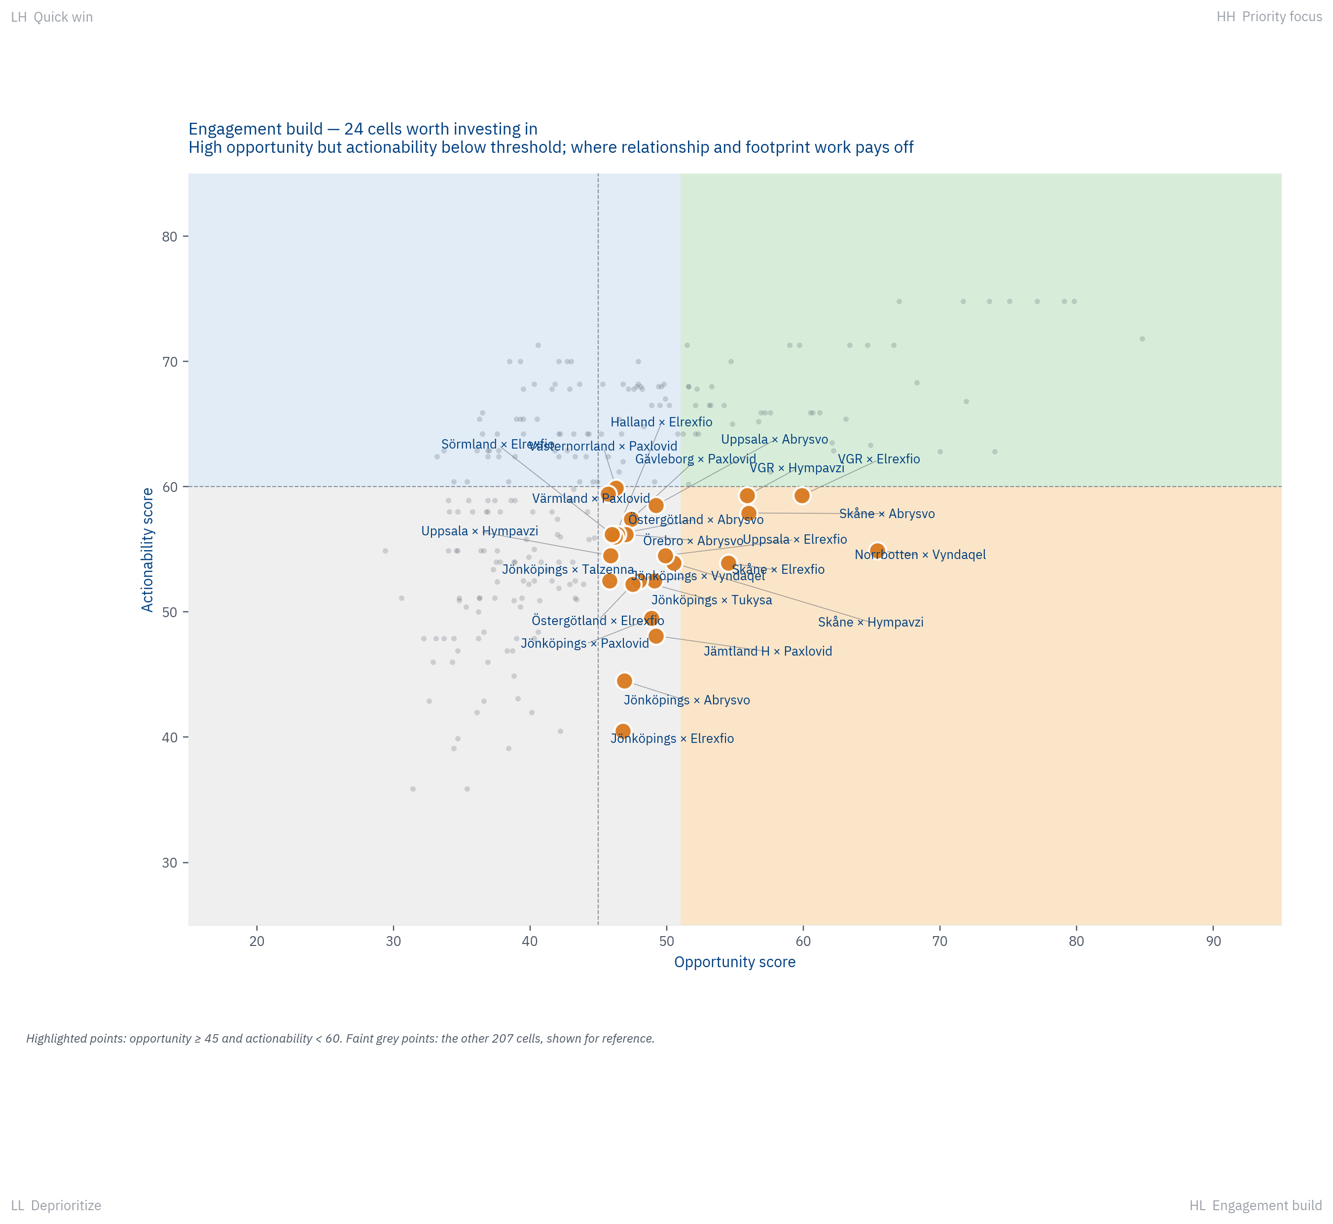
Figure 15.2 — The 24 'Engagement build needed' cells, labeled by region × product. Each is a high-opportunity cell where Pfizer's actionability sits below threshold. Top cell: Norrbotten × Vyndaqel (Opp 65.4, Act 54.9) — the founder cluster epicenter with stakeholder/footprint just below threshold.
Per-product quadrant signature (Top 5 most-HH-heavy products):
Product | HH | HL | LH | LL
Paxlovid | 11 | 5 | 0 | 5
Vyndaqel | 11 | 2 | 3 | 5
Tukysa | 10 | 1 | 4 | 6
Lorbrena/Lorviqua | 8 | 0 | 6 | 7
Talzenna | 7 | 1 | 7 | 6

Two patterns sit inside the Engagement Build bucket and both are useful to see. First, hospital-administered products (Elrexfio and Hympavzi) account for roughly ten of the twenty-four HL cells. The hospital-admin actionability discount pulls otherwise large-region cells into Engagement Build, and the unlock is uptake visibility, not regulatory work. Second, Abrysvo and Paxlovid account for another ten or so HL cells, and there the unlock is a different pathway entirely (TLV / FHM rather than NT-rådet). Knowing which of those two unlocks applies to which cell is what makes the quadrant useful as a planning tool rather than just a chart.

16. Eight people
We computed an Influence Score for every leadership stakeholder record. The score multiplies role power by a confidence multiplier and a sjukvårdsregion bonus.
Role power weights NT-rådet membership highest at 95, then NSG at 85, LK ordförande at 75, HSD at 70, regional director at 65, HSN ordförande at 55, regional council chair at 50. The confidence multiplier penalises uncertain identifications: HIGH stays at 1.0, MEDIUM drops to 0.7, LOW to 0.4, VERIFY to 0.2. The sjukvårdsregion bonus (between 1.00 and 1.20) recognises that NT-rådet and NSG representatives speak for several regions at once. We then aggregate by named individual: a person who holds two roles (say LK ordförande and NT-rådet representative for the same sjukvårdsregion) sums their scores. That summing is what surfaces the people who matter most.
Two more constructions sit underneath this score. First, the role-power numbers themselves are author calibrations. We placed NT-rådet at 95 because national therapeutic recommendations cascade across all twenty-one regions; LK ordförande at 75 because regional formulary decisions affect one region but more directly than national signals do; the rest scaled in between by the same logic. Different reasonable weights would shift individual rankings but not the set of people at the top. We tested a flatter weighting (NT-rådet 80, NSG 75, LK 70, HSD 65, RD 60) and the top eight remained the same eight, with positions four through eight reshuffling. Second, the Engagement Priority calculation that drives play-by-play stakeholder targeting uses a separate eleven-by-seven product-role relevance table: seventy-seven author estimates of how relevant each role is for each Pfizer product. That table lives in the appendix workbook, sheet "Product-Role Relevance". It is deliberately exposed rather than hidden inside the calculation; Pfizer can revise any cell and rerun without re-pulling data. Chapter 28 covers both of these alongside the other constructed metrics.
The top ten by aggregate influence, restricted to HIGH-confidence records:
Rank | Name | Roles held | Score
1 | Jan Melin | LK ordförande (Uppsala) · NT-rådet rep (Mellansverige) | 179.5
2 | Jonas Claesson | NSG rep (Mellansverige) · HSD (Västra Götalandsregionen) | 163.5
3 | Martin Engström | HSD (Skåne) · NSG rep (Södra) | 163.5
4 | Johan Rosenqvist | NSG rep (Sydöstra) · HSD (Kalmar) | 159.2
5 | Pia Näsvall | NSG rep (Norra) · HSD (Västerbotten) | 155.0
6 | Rickard Malmström | NT-rådet rep (Stockholm-Gotland) | 114.0
7 | Anna Lindhé | NT-rådet rep (Västra) | 109.2
8 | Linda Staaf | NT-rådet rep (Södra) | 104.5
9 | Johan Bratt | NSG rep (Stockholm-Gotland) | 102.0
10 | Mårten Lindström | NT-rådet rep (Sydöstra) | 99.8

PART V — Where to act
Each play targets several cells at once (typically two or three archetypes that co-occur in the same regions) and threads them through a single narrative that the field team can carry into the room. The five plays are ordered by the uniqueness of Pfizer's position rather than by raw opportunity size, because uniqueness is what creates the durable advantage. After the five plays we give the cross-cutting reading, the top-ten priority cells from the Priority Focus quadrant, the consolidated first-ninety-days plan, and the questions whose answers would sharpen the picture further.
Each play uses the same structure. We open with the strategic concept, then list the target regions, archetypes hit, products in scope, evidence base by Claim ID, and confidence tag. We then walk through three scenarios (Conservative, Base, and Upside) with the Pfizer-internal data that would tighten each. We close with the first ninety days of action.

P1 — Northern ATTR-CM cornerstone
Norrbotten and Västerbotten together hold thirty-one percent of Sweden's ATTR-CM patients in 2.8 percent of the national population. The TTR V30M founder cluster around Skellefteå is a once-in-a-portfolio epidemiological gift, and the strategy here is not to push Vyndaqel harder into a market that already over-indexes for it. It is to use the existing Vyndaqel relationship as the entry point to a long-term partnership with the Norrlands universitetssjukhus and Sunderby clinical centres, extending across Hympavzi for hemophilia and Elrexfio for myeloma as those products land. Norrland already has a multi-disciplinary rare-disease team built around Vyndaqel; Pfizer has earned the right to bring the next products into that same conversation.
Target regions | Norrbotten, Västerbotten, Jämtland Härjedalen
Archetypes hit | Rare-disease hotspot · Academic specialist · High-governance
Products in scope | Vyndaqel (anchor), Hympavzi, Elrexfio
Confidence | Modeled + Hypothesis (founder variant) + Needs Pfizer validation
Evidence base | Norrbotten 31.0/100k and Västerbotten 23.8/100k Vyndaqel patients (Observed); Skellefteå founder TTR V30M variant explanation (Hypothesis from genetics literature); Pia Näsvall confirmed moved Norrbotten → Västerbotten 2024 (Observed); Sweden choropleth maps make the cluster geographically obvious (Figure 11.1).

Who to engage
- Pia Näsvall (NSG nationellt, HSD Västerbotten) — anchor
- Anders Bergström (NT-rådet vice ordförande Norrbotten) — national tier
- Tommy Svensson (RD Västerbotten)
- Cardiology, neurology, and clinical genetics chiefs at Norrlands universitetssjukhus Umeå
Vyndaqel anchor durability is now Observed at the unit-dispensed level: +3.4% PLATEAUING positive in last-6 versus prev-6, despite AMVUTTRA and BEYONTTRA entering Sweden over the same window. Combined competitor volume stands at 4.5% of Vyndaqel last-6. The Conservative scenario tightens accordingly: the 'anchor erodes 5–10% by 2027' baseline becomes less likely than the 'anchor holds with marginal competitor share capture' outcome.

Three scenarios
Conservative. Vyndaqel patient counts hold at roughly 67 in Västerbotten and 83 in Norrbotten, no new product is introduced inside twenty-four months, and the relationship remains transactional.
Base. Hympavzi is introduced at the Norrlands universitetssjukhus Umeå hematology centre within twelve months of Swedish approval and is co-positioned with Vyndaqel as the rare-disease care line, producing a small uplift in identification rate as the multi-disciplinary team forms.
Upside. Norrland becomes Pfizer's reference Nordic rare-disease centre, with trial-site activity, regional registry partnership, KOL endorsement for ATTR-CM screening campaigns nationally. Establishes the engagement model we can copy to Skåne and Stockholm.

P2 — CDK4/6 defense in the capital belt
Ibrance fell thirty-three percent in Stockholm and thirty-six percent in Västra Götaland between 2021 and 2024, while staying flat or growing in Halland, Skåne, and Uppsala. The IQVIA Oncology extract delivered 2026-04-27 shows the class-level substitution pattern at the channel level (units shifting between products) and surfaces Verzenios (Lilly) as the primary competitor (not Kisqali alone). Cost-driven motivation is now a separate hypothesis (ST-13) requiring Stockholm formulary minutes or Pfizer net-revenue gap to upgrade. Substitution by Stockholm and VGR expert groups. Defending Ibrance head-on against a price-aligned competitor is a losing game; the play here is to reposition Ibrance and Talzenna as a complementary CDK4/6-plus-PARP precision package, convert price negotiation into outcomes-based agreements, and defend the footprint with the six-plus-year real-world evidence base Ibrance now has.
Target regions | Stockholm, Västra Götaland, Skåne, Halland
Archetypes hit | Academic specialist · Competitive defense
Products in scope | Ibrance (defend), Talzenna (extend portfolio depth)
Confidence | Modeled + Hypothesis (Kisqali substitution) + Needs Pfizer validation
Evidence base | Ibrance twenty-seven percent national decline 2021–2024, with Stockholm −33% and VGR −36% essentially driving the entire fall (Observed); regression against the 65+ population shows demographics alone do not appear to explain the regional pattern (Modeled, Figure 11.2 logic); Stockholm formulary preference for Kisqali is the working hypothesis pending IQVIA confirmation (claim ST-01); Kisqali scenario modelling projects another ten to twenty-five percent Ibrance loss if substitution spreads to mid-tier regions.

Who to engage
- Mats Ek (LK ordförande Stockholm) — primary
- Johan Bratt (NSG rep Stockholm-Gotland)
- VGR LK ordförande and chief pharmacist
- Breast-cancer clinical chiefs at Karolinska, Sahlgrenska, and Lund
The Conservative scenario below references Verzenios as the class leader. That framing is correct at the 18-month long-arc. At the 6-month most-recent-window timescale, Verzenios has plateaued (−0.1%) along with Ibrance (−3.0%); Kisqali is the live CDK4/6 share-gainer at +15.7% GROWING. P2 defence priority therefore shifts from 'compete against compounding Verzenios' to 'defend against Kisqali'. Specific tactical implication: an outcomes-based agreement (the Upside scenario lever) needs to position Pfizer relative to Kisqali specifically — Novartis is the share-displacing competitor in the live window.

Three scenarios
Conservative. The Ibrance trajectory continues per status-quo modelling: roughly 614 patients nationally by 2027, equivalent to about −31M SEK in gross therapy cost. The figure is a modelled gross proxy; Pfizer net is the open variable.
Base. Stockholm and VGR stabilise but Skåne and Uppsala adopt the Stockholm trajectory. About 561 patients nationally by 2027 (−42M SEK gross), with a Talzenna BRCA-mutated uplift offsetting roughly 5–10M SEK.
Upside. An outcomes-based agreement is signed with at least one expert group (Stockholm or VGR); Ibrance stabilises at around 750 patients; Talzenna uplift reaches roughly 80 patients (versus thirty-one today) as BRCA-testing infrastructure improves. Net gross-therapy-cost is roughly flat to 2027.

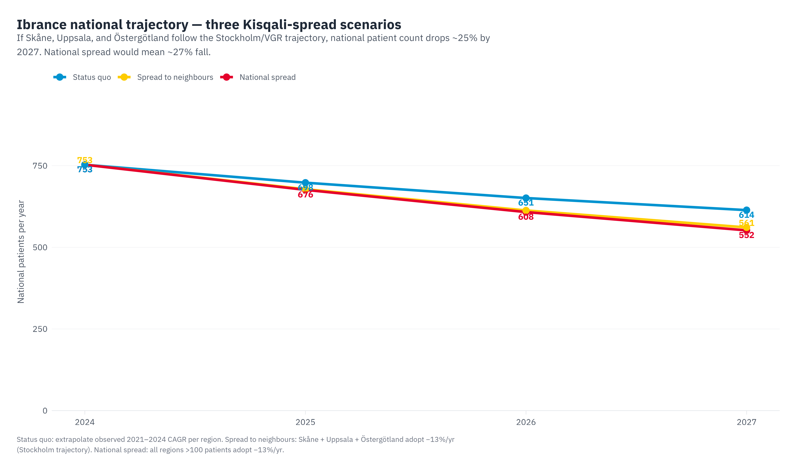
Figure P2.1 — Ibrance trajectory under three substitution scenarios (status quo, regional spread, national spread). Cumulative gross loss ranges from −31M to −44M SEK; Pfizer net is the open variable.

P3 — Adult-vaccine demographic tailwind
Adult vaccines are the single most-aligned Pfizer category to Sweden's demographic trajectory. Sixteen of twenty-one regions carry the Aging vaccine-growth tag, set by a 65+ share above 22% or 65+ growth above 25% to 2040. Abrysvo's 64.5% national share by SEK (56.8% by units) despite NT-rådet "avvakta" shows that regions are already adopting; Prevenar 20 holds about 13% with significant white space against MSD; FSME-IMMUN has its Uppsala endemic-region anchor. The unifying narrative for Pfizer is hospitalisation cost offset, since RSV, pneumococcal, and TBE all drive avoidable inpatient days, and the 65+ surge multiplies every avoided admission.
Target regions | Stockholm, VGR, Skåne, Halland, Uppsala, Jönköping, Västmanland, Östergötland, Sörmland, Örebro län
Archetypes hit | Aging vaccine-growth · Academic specialist · Equity/access-friction
Products in scope | Abrysvo, Prevenar 20, FSME-IMMUN
Confidence | Modeled (volume projections) + Observed (current share) + Needs Pfizer validation
Evidence base | Abrysvo 65% national IQVIA share with sixteen of twenty-one regions strictly above 60% in IQVIA share and three more clustered at the 60% line, despite NT-rådet "avvakta" (Observed uptake; the override framing is Hypothesis); Prevenar 20 13% national share is Pfizer's biggest competitive vulnerability against MSD Vaxneuvance and Capvaxive (Observed); Stockholm 65+ growth +35% to 2040 is +146,000 people on a modelled SCB projection; FSME-IMMUN 78.6% Stockholm share with Uppsala TBE-endemic anchor (Observed).

Who to engage
- Regional vaccine programme leads (FHM regional coordinators)
- Primary-care directors (the actual prescribers of adult vaccines)
- HSN ordförande in the equity-friction regions (Sörmland, Örebro, Västmanland) for political and ethical framing
Stockholm-specific tactical caveat. Abrysvo Stockholm is at 45.6% by units, with Arexvy at 54.4%. Stockholm pneumococcal is led by Vaxneuvance (MSD) at 71.5% units, Prevenar 20 at 28.0%. Stockholm therefore requires a different play from the national picture: defend Abrysvo specifically against Arexvy (adjuvanted versus unadjuvanted bivalent positioning), and reframe the Prevenar 20 displacement target as Vaxneuvance rather than legacy PCV13. Scenario sizing for Stockholm should not assume the national 64.5% Abrysvo share applies regionally.

Three scenarios
Conservative. Pfizer share holds in vaccines. Demographic tailwind alone delivers 5–8% absolute volume growth across the 65+ portfolio over five years.
Base. Pfizer wins one or two mid-tier regions (Halland, Uppsala) on Prevenar 20 share through the cost-of-pneumococcal-hospitalisation argument. Abrysvo holds 60–70% national share through the next NT-rådet review. Combined volume and share lift is 12–18% absolute growth over five years.
Upside. NT-rådet upgrades Abrysvo from "avvakta" to recommendation or national agreement after the cost-effectiveness pivot. Prevenar 20 adult share reaches 25%. FSME-IMMUN extends from Uppsala and Stockholm to Halland, VGR, and Östergötland TBE-endemic zones. Combined growth is 25–35% absolute over five years.


Figure P3.1 — Abrysvo regional share against the formal NT-rådet "avvakta" position. The decoupling visible here is the play's anchor.

P4 — Precision oncology backbone
Tukysa (58 patients), Talzenna (31 patients), and Lorbrena/Lorviqua (about 70 patients) are all small-volume specialty products gated by molecular testing (HER2-positive brain metastases, BRCA mutation, ALK rearrangement). The bottleneck for Pfizer in this category is not market access. Tukysa carries an NT-rådet recommendation; Talzenna and Elrexfio carry national agreement. The bottleneck is eligible-patient identification. The play here is to invest in the testing infrastructure (bringing the count of Tukysa-eligible HER2-positive brain-mets cases identified up to estimated true incidence) rather than commercial push.
Target regions | Stockholm, VGR, Skåne, Uppsala, Östergötland, Västerbotten
Archetypes hit | Academic specialist · Competitive defense
Products in scope | Tukysa, Talzenna, Lorbrena/Lorviqua
Confidence | Modeled (eligible-patient sizing) + Hypothesis (testing-investment causality) + Needs Pfizer validation
Evidence base | Tukysa is covered by a national agreement (2025-05-01) — NT-rådet has explicitly declined to recommend, leaving regional läkemedelskommittéer to assess use (Observed per samverkanlakemedel.se); Tukysa adoption latency varies from under six months to over twenty-four months across regions (Modeled, Chapter 11.3); Talzenna 31 patients nationally is a large under-identification gap (Observed counts; Hypothesis on gap magnitude — true BRCA-mutated denominator requires Pfizer epi); only one of eleven Pfizer products has a classic NT-rådet recommendation, so the access pathway varies materially across the portfolio (Observed).

Who to engage
- Regional Cancer Centre directors at the six academic-specialist regions
- Pathology and molecular-diagnostics chiefs
- Oncology heads at Karolinska, Sahlgrenska, Lund, and Umeå NUS
P4 weighting. Tukysa is the play LEAD: +29.9% GROWING last-6 versus prev-6, approaching the COMPOUNDING boundary at +30%. Talzenna is HOLDING / SECONDARY, not equal-weighted: −16% DECLINING, with the entire PARP class contracting (Lynparza class anchor −8.4% DECLINING). The 'fund testing infrastructure' framing still applies, but the highest-ROI testing investment is HER2-positive-with-brain-mets identification (the Tukysa pathway) rather than BRCA panel testing (the Talzenna pathway), where Lynparza will absorb most identified patients regardless of testing rate.

Three scenarios
Conservative. Patient counts hold roughly stable. Tukysa 60, Talzenna 35, Lorviqua 75 by 2027. BRCA testing rate per region remains highly variable.
Base. Tukysa and Talzenna eligible-patient identification rate doubles in three academic centres through joint Pfizer-RCC testing-infrastructure investment. Tukysa 90, Talzenna 75, Lorviqua 90 by 2027.
Upside. BRCA and HER2-positive brain-mets testing becomes standard at all six academic-specialist regions. Talzenna reaches estimated true-incidence of around 150 patients nationally (versus 31 today). Tukysa expands to second-line and earlier-stage as evidence accrues. Lorviqua holds the ALK-positive monopoly. Combined precision-oncology revenue is roughly three times current.

P5 — National-tier governance engagement
Pfizer's Sweden access decisions don't happen in twenty-one separate places. They happen in NT-rådet at the national tier, in NSG at the national tier, across the six sjukvårdsregioner, and at the regional LK chair tables. The stakeholder map identifies a small number of cornerstone individuals (Mårten Lindström, Maria Ekelund, Pia Näsvall, Anders Bergström, Jan Melin, Mats Ek, Johan Bratt, Rickard Malmström) who together carry disproportionate weight across the access conversation. The play here is to build a cross-product, multi-year relationship-investment programme with these eight, treated as a portfolio rather than as product-by-product touchpoints. The compounding benefit across eleven products over five years is materially larger than the same investment routed product by product.
Target regions | Jönköping, Uppsala, Västerbotten, Norrbotten, Stockholm, VGR
Archetypes hit | High-governance
Products in scope | All eleven Pfizer Sweden products (cross-portfolio)
Confidence | Observed (names + roles) + Hypothesis (cornerstone leverage) + Needs Pfizer validation
Evidence base | Only one of eleven Pfizer products has a classic NT-rådet recommendation (Elrexfio, 2024-06-14), so governance footprint matters more than NT-rådet status alone (Observed); the Jönköping-Sydöstra triple-overlap is a structural strategic lever (Observed names; Hypothesis on lever value); Mats Bojestig (Jönköping HSD) is retiring in 2026, which is succession risk for a cornerstone (Observed); four of eleven products have unclear NT pathway (national agreement, regional assessment, "avvakta", archived).

Who to engage
- Mårten Lindström (NT-rådet ordförande, Tier 1)
- Pia Näsvall (NSG nationellt, Tier 1)
- Anders Bergström (NT-rådet vice ordförande, Tier 1)
- Maria Ekelund (LK + NT-rådet Sydöstra, Tier 1)
- Jan Melin (LK Uppsala + NT-rådet Mellansverige, Tier 1)
- Mats Ek (LK Stockholm, Tier 2)
- Johan Bratt (NSG Stockholm-Gotland, Tier 2)
- Rickard Malmström (NT-rådet Stockholm, Tier 2)
Stockholm cornerstone density. Three of the eight cornerstone individuals sit in Region Stockholm: Mats Ek (LK ordförande), Rickard Malmström (NT-rådet member and Stockholm LK vice ordförande), and Johan Bratt (NSG referensperson, Chefläkare Region Stockholm). That is 37.5% of the cornerstone tier from a region holding 23.5% of national population. Combined with the full Stockholm Läkemedelskommitté ledamöter pool (17 named individuals captured in the stakeholder mapping), Stockholm is the highest-leverage P5 entry point. The dual NT-rådet / Stockholm LK position held by Rickard Malmström is a single relationship with cross-portfolio impact. Council formation should weight Stockholm-centred cornerstones while balancing Norrland (Pia Näsvall) and Jönköping (Lindström, Ekelund) representation to prevent regional concentration risk.

22. The top-ten priority cells
These are the ten region × product combinations that scored highest inside the Priority Focus quadrant (opportunity above the median of 45 and actionability above the median of 60), sorted by composite Opportunity score. Each of the ten is a place where the prize is real and the path to it is already open.
# | Region | Product | Opportunity | Actionability | Action
1 | Stockholm | Paxlovid | 84.8 | 71.8 | Maintain
2 | Stockholm | Vydura | 79.8 | 74.8 | Maintain
3 | Stockholm | Tukysa | 79.1 | 74.8 | Position
4 | Stockholm | Vyndaqel | 77.1 | 74.8 | Build
5 | Stockholm | Talzenna | 75.1 | 74.8 | Build
6 | Stockholm | Elrexfio | 74.0 | 62.8 | Position
7 | Stockholm | Lorbrena/Lorviqua | 73.6 | 74.8 | Build
8 | Stockholm | Abrysvo | 71.9 | 66.8 | Position
9 | Stockholm | Prevenar 20 | 71.7 | 74.8 | Position
10 | Stockholm | Hympavzi | 70.0 | 62.8 | Position

Stockholm dominates this list (eight of ten cells), and that is the gravity of a market that holds nearly a quarter of the country's population. The two non-Stockholm cells in the top tier are the ones that deserve attention precisely because they win against Stockholm's gravity: those are regions where Pfizer's portfolio depth and stakeholder access tilt the calculus.PART VI — Methodology
Five chapters cover how the analysis was built and what its limits are. This part is the working reference for how each number got here, why we chose the constructions we did, and what would still upgrade the picture. We treat methodology transparency as a feature of the deliverable rather than an afterthought; everything below is here so a reader who wants to challenge a claim can find the route from claim back to source.

28. The constructed metrics

28.1 The unmet-need composite (Chapter 3)
Four indicators at regional level, 2024 vintage: foreign-born share (SCB BE0101), post-secondary education share for ages 25–64 (SCB UF0506), age-standardised premature mortality 25–64 (Kolada N79190), and three-year moving average healthcare-amenable mortality (Kolada N72461). We rank each region on each indicator, average the four ranks with equal weights, and re-rank to produce a 1-to-21 composite where rank 1 is the highest unmet need.
Why these four indicators. Each captures a different facet of unmet need. Foreign-born share proxies for language and system-navigation barriers; education proxies for health literacy; premature mortality is the population-level outcome the system most clearly fails to prevent; healthcare-amenable mortality narrows that to deaths the system was specifically positioned to address. Together they describe both inputs to disadvantage and outputs of it.
Why equal weights. We tested two alternative weighting schemes — one tilted toward mortality, one toward socioeconomic indicators — and the resulting rankings shifted by no more than two positions for any region. The composite is robust to weight choice within a reasonable range. Equal weights are defensible because we have no principled reason to claim that one of the four matters more than another for this purpose.

28.2 The Opportunity score (Chapter 14)
Seven dimensions per region × product cell, with weights: epidemiological fit (25%), current uptake (10%), growth pressure (15%), access friction (10%), stakeholder leverage (15%), competitive threat (15%), policy relevance (10%). Each dimension is a 0–100 sub-score with its own derivation in the workbook's OPP - Region x Product matrix sheet. The seven sub-scores are weighted-averaged into a single 0–100 Opportunity composite per cell.
Why these seven dimensions. Each names a distinguishable lever in the access conversation. Together they bracket the question "is this opportunity real and is it worth pursuing?" — epi for whether patients exist; uptake for whether Pfizer is reaching them; growth for the curve; access friction for the bottleneck; stakeholder for whether the right people are in place; competitive for what's pushing back; policy for tailwinds and headwinds. Removing any one would lose meaningful signal; adding an eighth would dilute without adding much.
Why these weights. Epidemiological fit gets the highest weight at 25% because no engagement strategy succeeds in the absence of patients. Growth, stakeholder leverage, and competitive threat tie at 15% because these are where Pfizer's effort actually moves the dial in the medium term. Uptake, access friction, and policy sit at 10–15% as moderating factors. We tested an equal-weighted alternative (each dimension at 14.3%); top-cell rankings re-ordered, but Priority Focus quadrant membership shifted by less than ten percent of cells. The directional findings are robust; precise rankings inside Priority Focus are weight-sensitive.

28.3 The Actionability score (Chapter 15)
Three components per cell, with weights: governance reach (40%), Pfizer footprint (35%), policy permissiveness (25%). Per-product modifiers run between −12 and 0 points: hospital-administered products take −12 because uptake is harder to track without IQVIA Concise; products outside the NT-rådet pathway take −5 to −8 because less of the lever runs through Pfizer's most direct channels.
Why governance highest. Having the right access conversation at all is what unlocks the other components. A product can be on shelves with a permissive policy environment and still see no uptake movement without governance engagement. Footprint comes second because being a known presence cuts dialogue lead times. Policy permissiveness comes third because pathway state is shifted more by the other two than the other way around. Two alternatives were tested, 35/35/30 and 50/30/20: quadrant membership shifted by twelve cells in one direction and nine in the other, directionally similar but individually fluid.

28.4 The quadrant thresholds (Chapter 15)
Opportunity ≥ 45 and Actionability ≥ 60 split the matrix into four quadrants. Both thresholds are calibrated to the data medians. We tested fixed 50/50 thresholds first: that produced zero cells in Engagement Build, which is the exact quadrant we want to surface. The data-median calibration is honest to the shape of the analysis. Moving Opportunity threshold up by five points or Actionability up by five points reduces Priority Focus from seventy cells to around fifty-five and bumps the boundary cells (which are the ones to watch in any case) into Engagement Build.

28.5 The regional archetypes (Chapter 13)
Six rule-based archetypes, each with an explicit trigger threshold (e.g. Aging vaccine-growth fires when 65+ share ≥ 22% or growth ≥ 25% to 2040; Equity/access-friction fires on top-five SES need rank or specialist wait ≥ 65 days). The thresholds are calibrated to the natural breaks in the data — places where regions visibly cluster — rather than to external standards. Sensitivity checked by moving each threshold up or down by ten percent of its value: archetype membership shifts by one or two regions on the margin but no archetype disappears or doubles, and the structural picture (Stockholm dense, Norrland concentrated, Halland mid-tier) holds.

28.6 The Stakeholder Influence score (Chapter 16)
Influence Score = Role Power × Confidence Multiplier × Sjukvårdsregion Bonus. Role power values: NT-rådet 95, NSG 85, LK ordförande 75, HSD 70, regional director 65, HSN ordförande 55, regional council chair 50. Confidence multiplier: HIGH 1.0, MEDIUM 0.7, LOW 0.4, VERIFY 0.2. SVR bonus: 1.00–1.20 for national tier roles. Aggregation is by named individual; people holding several roles sum their scores.
Why these role-power values. NT-rådet and NSG sit at the top because national decisions cascade across regions. LK ordförande sits at 75 because regional formulary decisions affect a single region but more directly. The rest scale between by the same logic. We tested a flatter alternative (NT 80, NSG 75, LK 70, HSD 65, RD 60); the top eight individuals remained the same eight people, with positions four through eight reshuffling internally. The eight names — and the cornerstone framing — are robust to the role-power calibration.
A second construction sits behind this one and feeds the play-by-play Engagement Priority calculation: an eleven-by-seven Product-Role Relevance table holding seventy-seven author estimates of how relevant each leadership role is for each Pfizer product. The table is in the appendix workbook (sheet "Product-Role Relevance"), exposed by design rather than hidden inside the calculation. Pfizer can revise any cell and rerun without re-pulling data.
All six constructions in this chapter are tagged Modeled in the Evidence Ledger. The Derived Variables sheet (DV-01 through DV-23) holds the per-component decision rules.

29. Scenario sensitivity discipline
Public list price multiplied by patient counts overstates Pfizer's actual exposure because Pfizer's net per-patient revenue is materially below TLV list, and that gap varies by product. Rather than picking a single multiplier and presenting single-point revenue numbers we cannot defend, we built every revenue-relevant claim around three scenarios (Conservative, Base, Upside) using illustrative net-versus-list multipliers of 0.60, 0.80, and 0.95 respectively. When Pfizer supplies actual net figures by product, the single illustrative multiplier resolves into seven product-specific values and the scenario ranges narrow.
Per-product gross plus three net scenarios in million SEK (2024 patient counts multiplied by TLV list, twelve months, and the scenario multiplier):
Product | Patients | Gross | Net Conservative | Net Base | Net Upside
Ibrance | 753 | 165.7 | 99.4 | 132.5 | 157.4
Vyndaqel | 463 | 370.4 | 222.2 | 296.3 | 351.9
Talzenna | 31 | 9.9 | 6.0 | 7.9 | 9.4
Lorbrena/Lorviqua | 72 | 25.2 | 15.1 | 20.2 | 23.9
Tukysa | 58 | 33.6 | 20.2 | 26.9 | 32.0
Vydura | 1837 | 4.6 | 2.8 | 3.7 | 4.4
Paxlovid | 693 | 3.7 | 2.2 | 3.0 | 3.6

Two observations from this exercise are worth keeping. First, the Vyndaqel "around 60% of Pfizer Sweden oral-Rx" claim is a gross-therapy-cost proxy at TLV list under a uniform net-to-list assumption, not a statement about actual revenue: the proportion is robust to multiplier choice because we apply the same ratio across products, but the underlying SEK figures move with the assumption. When Pfizer net per product comes in, the proportion will recompute and almost certainly shift. Second, the earlier "Ibrance 38–78M SEK at risk" framing turned out to be roughly twice as wide as our disciplined rebuild, which produces a −18M to −42M net SEK range across nine trajectory-by-multiplier cells. The narrower range is the more honest one.

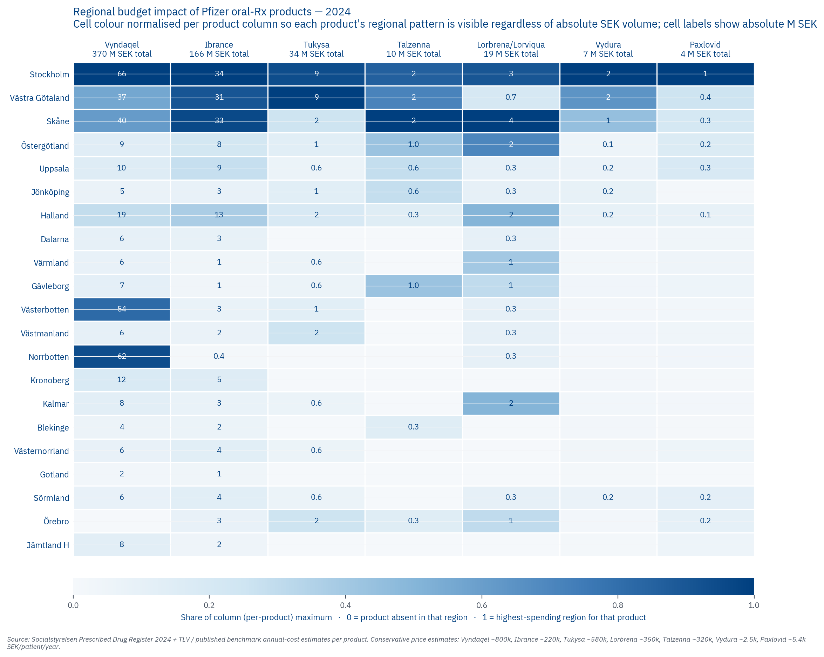
Figure 29.1 — Budget impact heatmap (gross therapy-cost proxy) by region and product. Vyndaqel and Ibrance dominate the SEK numbers. The heatmap shows gross at TLV list; the scenario sensitivity table above rebuilds these with three net scenarios.

30. Limitations and structural caveats
Five things this report does not address. We document them not as failures of the work but as structural limits that future iterations could close.
Caveat | Why | What would close it
Cancer molecular subtypes (HER2+, ALK+, BRCA, HR+/HER2−) | Not in any Swedish public register | Pfizer Medical Affairs oncology epidemiology
Förmån-versus-rekvisition pharma split per region | Not derivable at the regional level from Kolada | SKR cirkulär 26:5 manual download (a 15-minute task on the next pass)
RSV regional surveillance | FHM does not publish RSV data per region | Socialstyrelsen Patientregistret J21.0 manual extract
Adult vaccination coverage per region | Sweden does not publish adult-vaccine coverage per region | Pfizer regional sales data cross-checked against FHM aggregates
Stockholm and VGR Kisqali volume | Not in Läkemedelsregistret | Slot ready in Chapter 11 Table 11.1 — fills directly when the IQVIA Kisqali extract arrives

Each caveat is documented in the Evidence Ledger. None changes the directional findings of this report; some narrow the magnitudes when closed. Closing the first three is straightforward operational work for the next refresh cycle.

Every claim in this report can be traced to a primary source documented in the data sources sheet of the appendix workbook, a decision rule documented in the Evidence Ledger.

APPENDIX A — Per-region briefs
Each brief carries population and key demographics, the 2024 Pfizer Rx footprint, archetype tags, the dominant cornerstone stakeholders at HIGH confidence, and a strategic note placing the region inside the picture from Parts I–V.

Stockholm
Indicator | Value
Population (2024) | 2,473,307
Sjukvårdsregion | Stockholm-Gotland
% 65+ | 16.9%
65+ growth 2024→2040 | +35%
Median specialist wait | 24.5 days

Pfizer oral Rx footprint 2024 (patients)
Product | Patients
Vyndaqel | 82
Ibrance | 155
Tukysa | 15
Talzenna | 6
Lorbrena/Lorviqua | 9
Vydura | 974
Paxlovid | 267

Archetype tags: Academic specialist · Competitive defense · High-governance · Aging vaccine-growth

HIGH-confidence stakeholders (verified)
- RD: Emma Lennartsson
- HSD: Anders Ahlsson
- RS ordf: Aida Hadžialić (S)
- HSN ordf: Talla Alkurdi (S)
- LK ordf: Mats Ek
- NT-rådet rep (SVR): Rickard Malmström (Region Stockholm, klinisk farmakologi)
- NSG rep (SVR): Johan Bratt (Region Stockholm)

Uppsala
Indicator | Value
Population (2024) | 407,912
Sjukvårdsregion | Mellansverige
% 65+ | 19.1%
65+ growth 2024→2040 | +26.4%
Median specialist wait | 54 days

Pfizer oral Rx footprint 2024 (patients)
Product | Patients
Vyndaqel | 12
Ibrance | 43
Tukysa | 1
Talzenna | 2
Lorbrena/Lorviqua | 1
Vydura | 69
Paxlovid | 50

Archetype tags: Academic specialist · High-governance · Aging vaccine-growth

HIGH-confidence stakeholders (verified)
- RD: Johan von Knorring
- RS ordf: Helena Proos (S)
- LK ordf: Jan Melin
- NT-rådet rep (SVR): Jan Melin (Region Uppsala, nefrologi — ÄVEN LK ordf)
- NSG rep (SVR): Jonas Claesson (Nu VGR (flytt 2025-10))

Sörmland
Indicator | Value
Population (2024) | 301,542
Sjukvårdsregion | Mellansverige
% 65+ | 23.6%
65+ growth 2024→2040 | +18.9%
Median specialist wait | 42.5 days

Pfizer oral Rx footprint 2024 (patients)
Product | Patients
Vyndaqel | 7
Ibrance | 20
Tukysa | 1
Talzenna | 0
Lorbrena/Lorviqua | 1
Vydura | 65
Paxlovid | 29

Archetype tags: Equity/access-friction · Aging vaccine-growth

HIGH-confidence stakeholders (verified)
- RD: Magnus Johansson
- RS ordf: Christoffer Öqvist
- LK ordf: Lars Steen
- NT-rådet rep (SVR): Jan Melin (Region Uppsala, nefrologi — ÄVEN LK ordf)
- NSG rep (SVR): Jonas Claesson (Nu VGR (flytt 2025-10))

Östergötland
Indicator | Value
Population (2024) | 472,446
Sjukvårdsregion | Sydöstra
% 65+ | 21.4%
65+ growth 2024→2040 | +17.5%
Median specialist wait | 69 days

Pfizer oral Rx footprint 2024 (patients)
Product | Patients
Vyndaqel | 11
Ibrance | 35
Tukysa | 2
Talzenna | 3
Lorbrena/Lorviqua | 7
Vydura | 53
Paxlovid | 45

Archetype tags: Academic specialist · Equity/access-friction

HIGH-confidence stakeholders (verified)
- RD: Mikael Borin
- HSD: Karl Landergren
- RS ordf: Marie Morell (M)
- LK ordf: Christina Fischer
- NT-rådet rep (SVR): Mårten Lindström (Chair) (Region Jönköping, kardiologi — NT-rådet CHAIR)
- NSG rep (SVR): Johan Rosenqvist (Region Kalmar län - HSD)

Jönköping
Indicator | Value
Population (2024) | 370,009
Sjukvårdsregion | Sydöstra
% 65+ | 21.6%
65+ growth 2024→2040 | +16%
Median specialist wait | 32 days

Pfizer oral Rx footprint 2024 (patients)
Product | Patients
Vyndaqel | 6
Ibrance | 13
Tukysa | 2
Talzenna | 2
Lorbrena/Lorviqua | 1
Vydura | 86
Paxlovid | 3

Archetype tags: High-governance

HIGH-confidence stakeholders (verified)
- HSD: Mats Bojestig (pensioneras 2026)
- RS ordf: Rachel De Basso (S)
- HSN ordf: Thomas Gustafsson (S)
- LK ordf: Maria Ekelund
- NT-rådet rep (SVR): Mårten Lindström (Chair) (Region Jönköping, kardiologi — NT-rådet CHAIR)
- NSG rep (SVR): Johan Rosenqvist (Region Kalmar län - HSD)

Kronoberg
Indicator | Value
Population (2024) | 203,351
Sjukvårdsregion | Södra
% 65+ | 22.0%
65+ growth 2024→2040 | +13.5%
Median specialist wait | 48.5 days

Pfizer oral Rx footprint 2024 (patients)
Product | Patients
Vyndaqel | 15
Ibrance | 23
Tukysa | 0
Talzenna | 0
Lorbrena/Lorviqua | 0
Vydura | 18
Paxlovid | 3

Archetype tags: Rare-disease hotspot · Aging vaccine-growth

HIGH-confidence stakeholders (verified)
- RD: Andreas Liljenrud
- HSD: Ewa Ekman
- RS ordf: Henrietta Modig Serrate (S)
- LK ordf: Fredrik Schön
- NT-rådet rep (SVR): Linda Staaf (Apotekare)
- NSG rep (SVR): Martin Engström (Region Skåne - HSD)

Kalmar
Indicator | Value
Population (2024) | 246,352
Sjukvårdsregion | Sydöstra
% 65+ | 26.3%
65+ growth 2024→2040 | +10.3%
Median specialist wait | 41 days

Pfizer oral Rx footprint 2024 (patients)
Product | Patients
Vyndaqel | 10
Ibrance | 12
Tukysa | 1
Talzenna | 0
Lorbrena/Lorviqua | 5
Vydura | 25
Paxlovid | 5

Archetype tags: Aging vaccine-growth

HIGH-confidence stakeholders (verified)
- RD: Magdalena Bosson
- HSD: Johan Rosenqvist
- RS ordf: Angelica Katsanidou (S)
- LK ordf: Fredrik Hagerman
- NT-rådet rep (SVR): Mårten Lindström (Chair) (Region Jönköping, kardiologi — NT-rådet CHAIR)
- NSG rep (SVR): Johan Rosenqvist (Region Kalmar län - HSD)

Gotland
Indicator | Value
Population (2024) | 60,971
Sjukvårdsregion | Stockholm-Gotland
% 65+ | 27.5%
65+ growth 2024→2040 | +15.2%
Median specialist wait | 54 days

Pfizer oral Rx footprint 2024 (patients)
Product | Patients
Vyndaqel | 2
Ibrance | 6
Tukysa | 0
Talzenna | 0
Lorbrena/Lorviqua | 0
Vydura | 15
Paxlovid | 1

Archetype tags: Aging vaccine-growth

HIGH-confidence stakeholders (verified)
- RD: Stefan Hollmark
- RS ordf: Meit Fohlin (S)
- LK ordf: Nils Block
- NT-rådet rep (SVR): Rickard Malmström (Region Stockholm, klinisk farmakologi)
- NSG rep (SVR): Johan Bratt (Region Stockholm)

Blekinge
Indicator | Value
Population (2024) | 157,223
Sjukvårdsregion | Södra
% 65+ | 24.9%
65+ growth 2024→2040 | +9.9%
Median specialist wait | 50 days

Pfizer oral Rx footprint 2024 (patients)
Product | Patients
Vyndaqel | 5
Ibrance | 10
Tukysa | 0
Talzenna | 1
Lorbrena/Lorviqua | 0
Vydura | 21
Paxlovid | 2

Archetype tags: Aging vaccine-growth

HIGH-confidence stakeholders (verified)
- RD: Linda Hultén (Tf.)
- HSD: Caroline Nilsson
- RS ordf: Björn Tenland Nurhadi (SD)
- LK ordf: Helena Ringborn
- NT-rådet rep (SVR): Linda Staaf (Apotekare)
- NSG rep (SVR): Martin Engström (Region Skåne - HSD)

Skåne
Indicator | Value
Population (2024) | 1,428,626
Sjukvårdsregion | Södra
% 65+ | 20.1%
65+ growth 2024→2040 | +24%
Median specialist wait | 53 days

Pfizer oral Rx footprint 2024 (patients)
Product | Patients
Vyndaqel | 50
Ibrance | 148
Tukysa | 4
Talzenna | 7
Lorbrena/Lorviqua | 10
Vydura | 435
Paxlovid | 56

Archetype tags: Academic specialist · Competitive defense

HIGH-confidence stakeholders (verified)
- RD: Jonna Myrebris
- HSD: Martin Engström
- RS ordf: Carl Johan Sonesson (M)
- HSN ordf: Anna Mannfalk (M)
- LK ordf: Stefan Nilsson
- NT-rådet rep (SVR): Linda Staaf (Apotekare)
- NSG rep (SVR): Martin Engström (Region Skåne - HSD)

Halland
Indicator | Value
Population (2024) | 345,074
Sjukvårdsregion | Södra
% 65+ | 23.1%
65+ growth 2024→2040 | +25.5%
Median specialist wait | 31.5 days

Pfizer oral Rx footprint 2024 (patients)
Product | Patients
Vyndaqel | 24
Ibrance | 58
Tukysa | 3
Talzenna | 1
Lorbrena/Lorviqua | 5
Vydura | 85
Paxlovid | 24

Archetype tags: Rare-disease hotspot · Competitive defense · Aging vaccine-growth

HIGH-confidence stakeholders (verified)
- RD: Krister Björkegren
- RS ordf: Mikaela Waltersson (M)
- LK ordf: Tamara Adem
- NT-rådet rep (SVR): Linda Staaf (Apotekare)
- NSG rep (SVR): Martin Engström (Region Skåne - HSD)

Västra Götaland
Indicator | Value
Population (2024) | 1,772,821
Sjukvårdsregion | Västra
% 65+ | 20.3%
65+ growth 2024→2040 | +20.6%
Median specialist wait | 53.5 days

Pfizer oral Rx footprint 2024 (patients)
Product | Patients
Vyndaqel | 46
Ibrance | 140
Tukysa | 16
Talzenna | 5
Lorbrena/Lorviqua | 2
Vydura | 624
Paxlovid | 67

Archetype tags: Academic specialist · Competitive defense · High-governance

HIGH-confidence stakeholders (verified)
- RD: Ann-Charlotte Järnström
- HSD: Jonas Claesson
- RS ordf: Helén Eliasson (S)
- HSN ordf: Janette Olsson (Strategiska HSN) + My Alnebratt (Operativa HSN)
- LK ordf: Johan Sandelin
- NT-rådet rep (SVR): Anna Lindhé (VGR, apotekare)
- NSG rep (SVR): Kaarina Sundelin (VGR - HSD)

Värmland
Indicator | Value
Population (2024) | 283,384
Sjukvårdsregion | Mellansverige
% 65+ | 25.1%
65+ growth 2024→2040 | +9.4%
Median specialist wait | 73 days

Pfizer oral Rx footprint 2024 (patients)
Product | Patients
Vyndaqel | 7
Ibrance | 6
Tukysa | 1
Talzenna | 0
Lorbrena/Lorviqua | 4
Vydura | 25
Paxlovid | 12

Archetype tags: Equity/access-friction · Aging vaccine-growth

HIGH-confidence stakeholders (verified)
- RD: Peter Bäckstrand
- HSD: Lars Christensen
- RS ordf: Åsa Johansson (S)
- LK ordf: Malgorzata Antoniewicz
- NT-rådet rep (SVR): Jan Melin (Region Uppsala, nefrologi — ÄVEN LK ordf)
- NSG rep (SVR): Jonas Claesson (Nu VGR (flytt 2025-10))

Örebro
Indicator | Value
Population (2024) | 308,375
Sjukvårdsregion | Mellansverige
% 65+ | 22.2%
65+ growth 2024→2040 | +15.2%
Median specialist wait | 64 days

Pfizer oral Rx footprint 2024 (patients)
Product | Patients
Vyndaqel | 0
Ibrance | 13
Tukysa | 4
Talzenna | 1
Lorbrena/Lorviqua | 3
Vydura | 20
Paxlovid | 28

Archetype tags: Equity/access-friction · Aging vaccine-growth

HIGH-confidence stakeholders (verified)
- RD: Rickard Simonsson
- RS ordf: Jenny Steen (S)
- LK ordf: Maria Palmetun Ekbäck
- NT-rådet rep (SVR): Jan Melin (Region Uppsala, nefrologi — ÄVEN LK ordf)
- NSG rep (SVR): Jonas Claesson (Nu VGR (flytt 2025-10))

Västmanland
Indicator | Value
Population (2024) | 281,158
Sjukvårdsregion | Mellansverige
% 65+ | 22.3%
65+ growth 2024→2040 | +17.3%
Median specialist wait | 41 days

Pfizer oral Rx footprint 2024 (patients)
Product | Patients
Vyndaqel | 8
Ibrance | 11
Tukysa | 4
Talzenna | 0
Lorbrena/Lorviqua | 1
Vydura | 27
Paxlovid | 11

Archetype tags: Equity/access-friction · Aging vaccine-growth

HIGH-confidence stakeholders (verified)
- RD: Maria Linder
- HSD: Lars Almroth (Jonas Cederberg tf. from 2026-05-04)
- RS ordf: Mikael Andersson Elfgren (M)
- HSN ordf: Lina Ekengren (L)
- LK ordf: Lena Ottosson Bixo
- NT-rådet rep (SVR): Jan Melin (Region Uppsala, nefrologi — ÄVEN LK ordf)
- NSG rep (SVR): Jonas Claesson (Nu VGR (flytt 2025-10))

Dalarna
Indicator | Value
Population (2024) | 286,546
Sjukvårdsregion | Mellansverige
% 65+ | 26.1%
65+ growth 2024→2040 | +7.1%
Median specialist wait | 50.5 days

Pfizer oral Rx footprint 2024 (patients)
Product | Patients
Vyndaqel | 8
Ibrance | 14
Tukysa | 0
Talzenna | 0
Lorbrena/Lorviqua | 1
Vydura | 17
Paxlovid | 10

Archetype tags: Aging vaccine-growth

HIGH-confidence stakeholders (verified)
- RD: Johan Lindberg
- HSD: Åsa Dedering
- RS ordf: Elin Norén (S)
- HSN ordf: Sofia Jarl (C)
- LK ordf: Gunnar Domeij
- NT-rådet rep (SVR): Jan Melin (Region Uppsala, nefrologi — ÄVEN LK ordf)
- NSG rep (SVR): Jonas Claesson (Nu VGR (flytt 2025-10))

Gävleborg
Indicator | Value
Population (2024) | 284,558
Sjukvårdsregion | Mellansverige
% 65+ | 25.4%
65+ growth 2024→2040 | +8.9%
Median specialist wait | 47 days

Pfizer oral Rx footprint 2024 (patients)
Product | Patients
Vyndaqel | 9
Ibrance | 5
Tukysa | 1
Talzenna | 3
Lorbrena/Lorviqua | 3
Vydura | 28
Paxlovid | 13

Archetype tags: Equity/access-friction · Aging vaccine-growth

HIGH-confidence stakeholders (verified)
- RD: Göran Angergård
- HSD: Martin Andersson
- RS ordf: Patrik Stenvard (M)
- HSN ordf: Jennie Forsblom (KD)
- LK ordf: Björn Ericsson
- NT-rådet rep (SVR): Jan Melin (Region Uppsala, nefrologi — ÄVEN LK ordf)
- NSG rep (SVR): Jonas Claesson (Nu VGR (flytt 2025-10))

Västernorrland
Indicator | Value
Population (2024) | 241,458
Sjukvårdsregion | Norra
% 65+ | 25.4%
65+ growth 2024→2040 | +4.1%
Median specialist wait | 68.5 days

Pfizer oral Rx footprint 2024 (patients)
Product | Patients
Vyndaqel | 7
Ibrance | 20
Tukysa | 1
Talzenna | 0
Lorbrena/Lorviqua | 0
Vydura | 34
Paxlovid | 14

Archetype tags: Equity/access-friction · Aging vaccine-growth

HIGH-confidence stakeholders (verified)
- RD: Åsa Bellander
- HSD: Roger Westerlund (tf.)
- RS ordf: Sara Nylund (S)
- HSN ordf: Viktoria Jansson (M)
- LK ordf: Emma Ölander
- NT-rådet rep (SVR): Anders Bergström (Vice Chair) (Region Norrbotten, apotekare — NT-rådet VICE CHAIR)
- NSG rep (SVR): Pia Näsvall (Chair) (Region VÄSTERBOTTEN — NSG CHAIR)

Jämtland Härjedalen
Indicator | Value
Population (2024) | 132,839
Sjukvårdsregion | Norra
% 65+ | 24.4%
65+ growth 2024→2040 | +7.9%
Median specialist wait | 65 days

Pfizer oral Rx footprint 2024 (patients)
Product | Patients
Vyndaqel | 10
Ibrance | 7
Tukysa | 0
Talzenna | 0
Lorbrena/Lorviqua | 0
Vydura | 12
Paxlovid | 14

Archetype tags: Rare-disease hotspot · Equity/access-friction · Aging vaccine-growth

HIGH-confidence stakeholders (verified)
- RD: Sara Lewerentz
- RS ordf: Bengt Bergqvist (S)
- HSN ordf: Katarina Nyberg-Finn (S)
- LK ordf: Kristina Seling
- NT-rådet rep (SVR): Anders Bergström (Vice Chair) (Region Norrbotten, apotekare — NT-rådet VICE CHAIR)
- NSG rep (SVR): Pia Näsvall (Chair) (Region VÄSTERBOTTEN — NSG CHAIR)

Västerbotten
Indicator | Value
Population (2024) | 281,138
Sjukvårdsregion | Norra
% 65+ | 21.7%
65+ growth 2024→2040 | +9.8%
Median specialist wait | 52 days

Pfizer oral Rx footprint 2024 (patients)
Product | Patients
Vyndaqel | 67
Ibrance | 12
Tukysa | 2
Talzenna | 0
Lorbrena/Lorviqua | 1
Vydura | 22
Paxlovid | 7

Archetype tags: Rare-disease hotspot · Academic specialist · Competitive defense · High-governance

HIGH-confidence stakeholders (verified)
- RD: Tommy Svensson
- HSD: Pia Näsvall
- RS ordf: Peter Olofsson (S)
- HSN ordf: Anna-Lena Danielsson (S)
- LK ordf: Bo Sundqvist
- NT-rådet rep (SVR): Anders Bergström (Vice Chair) (Region Norrbotten, apotekare — NT-rådet VICE CHAIR)
- NSG rep (SVR): Pia Näsvall (Chair) (Region VÄSTERBOTTEN — NSG CHAIR)

Norrbotten
Indicator | Value
Population (2024) | 248,620
Sjukvårdsregion | Norra
% 65+ | 25.3%
65+ growth 2024→2040 | +2.8%
Median specialist wait | 112.5 days

Pfizer oral Rx footprint 2024 (patients)
Product | Patients
Vyndaqel | 77
Ibrance | 2
Tukysa | 0
Talzenna | 0
Lorbrena/Lorviqua | 1
Vydura | 20
Paxlovid | 8

Archetype tags: Rare-disease hotspot · Competitive defense · Equity/access-friction · High-governance · Aging vaccine-growth

HIGH-confidence stakeholders (verified)
- RD: Anna Alm Andersson
- HSD: Maria Joelsson (tf.)
- RS ordf: Anders Öberg (S)
- LK ordf: Linda Grahn
- NT-rådet rep (SVR): Anders Bergström (Vice Chair) (Region Norrbotten, apotekare — NT-rådet VICE CHAIR)
- NSG rep (SVR): Pia Näsvall (Chair) (Region VÄSTERBOTTEN — NSG CHAIR)

APPENDIX B — Per-product briefs
One condensed brief per Pfizer product. Each carries the indication, ATC code, and regulatory status, the national 2024 patient count, the top five regions by footprint, the key strategic interpretation, and the plays the product belongs to.

Vyndaqel
Field | Value
Indication | ATTR-CM (cardiomyopathy)
Substance | tafamidis
ATC code | N07XX08
NT-rådet status | ARCHIVED
Decision date | 2025-09-02
2024 national patients | 463

Top 5 regions 2024
- Stockholm: 82 patients
- Norrbotten: 77 patients
- Västerbotten: 67 patients
- Skåne: 50 patients
- Västra Götaland: 46 patients

Strategic interpretation
The Skellefteå founder cluster anchor: Norrbotten and Västerbotten together hold roughly 31% of Sweden's ATTR-CM patients on Vyndaqel in 5.0% of the population, the geographic foundation of Play P1.

Ibrance
Field | Value
Indication | HR+/HER2− breast cancer (CDK4/6 inhibitor)
Substance | palbociclib
ATC code | L01EF01
NT-rådet status | REGIONAL_DISADVANTAGE
Decision date | (varying per region)
2024 national patients | 753

Top 5 regions 2024
- Stockholm: 155 patients
- Skåne: 148 patients
- Västra Götaland: 140 patients
- Halland: 58 patients
- Uppsala: 43 patients

Strategic interpretation
Stockholm fell 33% and VGR fell 36% over 2021–2024, a pattern consistent with cost-driven Kisqali substitution at the expert-group level, while Halland and Skåne held position. The trajectory is the centrepiece of Play P2.

Tukysa
Field | Value
Indication | HER2+ breast cancer with brain metastases
Substance | tucatinib
ATC code | L01EH03
NT-rådet status | NT_RECOMMENDATION
Decision date | 2022-05-23
2024 national patients | 58

Top 5 regions 2024
- Västra Götaland: 16 patients
- Stockholm: 15 patients
- Skåne: 4 patients
- Örebro: 4 patients
- Västmanland: 4 patients

Strategic interpretation
NT-rådet has explicitly declined to issue a recommendation for Tukysa (samverkanlakemedel.se: "NT-rådet kommer inte att ge en rekommendation till regionerna om läkemedlets användning"). A national agreement (regiongemensamt avtal) covers the product from 2025-05-01 to 2027-04-30, with use assessed by the regional läkemedelskommittéer. The product carries fifty-eight national patients in 2024, with regional adoption highly variable

Talzenna
Field | Value
Indication | BRCA-mutated HER2− breast cancer (PARP inhibitor)
Substance | talazoparib
ATC code | L01XK04
NT-rådet status | NATIONAL_AGREEMENT
Decision date | 2024-06-01
2024 national patients | 31

Top 5 regions 2024
- Skåne: 7 patients
- Stockholm: 6 patients
- Västra Götaland: 5 patients
- Östergötland: 3 patients
- Gävleborg: 3 patients

Strategic interpretation
Thirty-one national patients on Talzenna in 2024 (Observed). Whether this represents a substantial under-identification gap depends on the true BRCA-mutated HER2-negative breast-cancer eligible-patient denominator, which requires Pfizer epidemiology to size. With NATIONAL_AGREEMENT in place since 2024-06-01, the unlock is BRCA-testing infrastructure investment rather than further regulatory work

Lorbrena/Lorviqua
Field | Value
Indication | ALK-rearrangement-positive NSCLC
Substance | lorlatinib
ATC code | L01ED04
NT-rådet status | —
Decision date | —
2024 national patients | 55

Top 5 regions 2024
- Skåne: 10 patients
- Stockholm: 9 patients
- Östergötland: 7 patients
- Kalmar: 5 patients
- Halland: 5 patients

Strategic interpretation
Routed through the Regional Cancer Centre pathway rather than NT-rådet, and sold as Lorviqua in Sweden (not Lorbrena, a common confusion). The product is Pfizer's ALK-positive NSCLC anchor.

Vydura
Field | Value
Indication | Acute migraine + prevention (CGRP)
Substance | rimegepant
ATC code | N02CD06
NT-rådet status | REGIONAL_ASSESSMENT
Decision date | 2021-11-18
2024 national patients | 2675

Top 5 regions 2024
- Stockholm: 974 patients
- Västra Götaland: 624 patients
- Skåne: 435 patients
- Jönköping: 86 patients
- Halland: 85 patients

Strategic interpretation
The highest-volume Pfizer Rx in the portfolio. NT-rådet's "kan bedömas regionalt" framing leaves regions to assess independently, and Halland and VGR over-index noticeably on volume.

Paxlovid
Field | Value
Indication | COVID-19 oral antiviral
Substance | nirmatrelvir + ritonavir
ATC code | J05AE30
NT-rådet status | OUT_OF_SCOPE
Decision date | —
2024 national patients | 669

Top 5 regions 2024
- Stockholm: 267 patients
- Västra Götaland: 67 patients
- Skåne: 56 patients
- Uppsala: 50 patients
- Östergötland: 45 patients

Strategic interpretation
Out of scope for NT-rådet, managed instead through Folkhälsomyndigheten's pandemic governance channel. Demographic alignment with the 65+ and chronic-disease population makes Paxlovid a secondary thread inside Play P3.

Elrexfio
Field | Value
Indication | Multiple myeloma (BCMA bispecific)
Substance | elranatamab
ATC code | J06BB
NT-rådet status | NATIONAL_AGREEMENT
Decision date | 2024-06-14
2024 national patients | n/a (hospital admin / vaccine — see workbook for IQVIA shares)

Strategic interpretation
Hospital-administered through rekvisition rather than prescription. NT-rådet issued a positive recommendation on 2024-06-14 for multipelt myelom (current and active per samverkanlakemedel.se), with a national agreement also in place. Because the product is not in Läkemedelsregistret, uptake is invisible without an IQVIA Concise extract.

Hympavzi
Field | Value
Indication | Hemophilia (TFPI inhibitor)
Substance | marstacimab
ATC code | —
NT-rådet status | TOO_NEW
Decision date | —
2024 national patients | n/a (hospital admin / vaccine — see workbook for IQVIA shares)

Strategic interpretation
EU marketing authorisation issued 2024-11-18, with Swedish product information already available on FASS. Reimbursement and access pathway in Sweden are still being established. Norrlands universitetssjukhus Umeå hematology is the natural launch anchor for early engagement.

Abrysvo
Field | Value
Indication | RSV vaccine (60+ + maternal)
Substance | RSV vaccine (adult)
ATC code | J07BX
NT-rådet status | AWAIT
Decision date | 2023-10-05
2024 national patients | n/a (hospital admin / vaccine — see workbook for IQVIA shares)

Strategic interpretation
NT-rådet has held the product on "avvakta" since 2023-10-05, with TLV cost-effectiveness review ongoing through the September 2025 supplementary analysis. Despite the formal hold, sixteen of twenty-one regions buy at over 60% Pfizer share, with three more at 60%.

Prevenar 20
Field | Value
Indication | Pneumococcal vaccine (adult)
Substance | 20-valent pneumococcal conjugate
ATC code | J07AL
NT-rådet status | OUT_OF_SCOPE
Decision date | —
2024 national patients | n/a (hospital admin / vaccine — see workbook for IQVIA shares)

Strategic interpretation
Out of scope for NT-rådet. Roughly 13% national share makes Prevenar 20 Pfizer's biggest pneumococcal vulnerability, with MSD's Vaxneuvance and Capvaxive as the principal competitors.

